School Name
Yearly Examination
2015
Year 10

Advanced Mathematics Course
General Instructions  - Reading time: 5 minutes  - Working time: 2 hours  - There will be a short break between Section 1 and Section 2  - Write using black or blue pen  - You may use a pencil to draw or complete diagrams  - Attempt ALL questions  - Approved calculators may be used in Section 2.  - Write your Name and Teacher’s Name in the spaces provided.  - A formula Sheet is on the reverse of this page and can be detached and used in all sections of the test. | Total Marks – 100  Section 1  Non Calculator Section.  25 marks  Time allowed for this section is 30 minutes.  Write all answers in the spaces provided.  Section 2  Time allowed for this section is 1 hour and 30 minutes.  Part A  Multiple Choice Section.  Mark your answers on the separate answer sheet at the end of the examination.  50 marks  Part B  Longer Answer Section.  Write all answers in the spaces provided.  25 marks

Formula Sheet
Pythagoras’ Theorem
c = hypotenuse
a and b are the shorter sides

Circumference of a circle
d = diameter

Area of a circle
r = radius

Area of a parallelogram
b = base
h = perpendicular height

Area of a rhombus or kite
x and y are the diagonals

Area of a trapezium
h = perpendicular height
a and b are the parallel sides

Volume of a prism
A = area of base
h = perpendicular height

Volume of a pyramid
A = area of base
h = perpendicular height

Volume of a cylinder
r = radius
h = perpendicular height

Volume of a cone

Volume of a sphere
Surface Area of a Cylinder

Surface Area of Cone
r = radius
l = slant height

Surface Area of a sphere

Trigonometric formulae for a triangle ABC.

Sine Rule

Cosine Rule
or
Area of a triangle
Simple interest
P = Principal
R = interest rate per time period as a decimal
T = number of time periods

Compound Interest
A = Final amount to which the investment grows
P = Principal
r = interest rate per compounding period as a decimal
n = number of compounding periods
Depreciation
SV = Salvage Value to which the initial value falls
IV = Initial Value
r = depreciation rate per compounding period as a decimal
n = number of compounding periods

Gradient of a line
and are points on the line
m = gradient

Midpoint of a line segment

Length of a line segment
Equation of a line
or
b = y intercept

School Name
Yearly Examination
Year 10
Advanced Mathematics Course
2015

Class/Teacher ______________________

Name______________________

Section 1

25 marks
Time allowed for this section is 30 minutes

Answer Questions 1–25 in the spaces provided.

Calculators are NOT to be used in this section.

There will be a short break between Section 1 and Section 2.

Section 1 Non Calculator Section
 | Write all working and answers in the spaces provided on this test paper.
1. | Write a decimal which is equivalent to 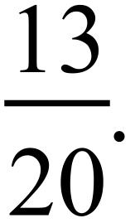  ……………………………………………………………………………………………....  ……………………………………………………………………………………………….
2. | Find 32% of $125.  ……………………………………………………………………………………………....  ……………………………………………………………………………………………….
3. | Samantha is paid at a wage rate of $24.00 per hour. What would she earn for working a 40 hour week?  ……………………………………………………………………………………………....  ……………………………………………………………………………………………….
4. | 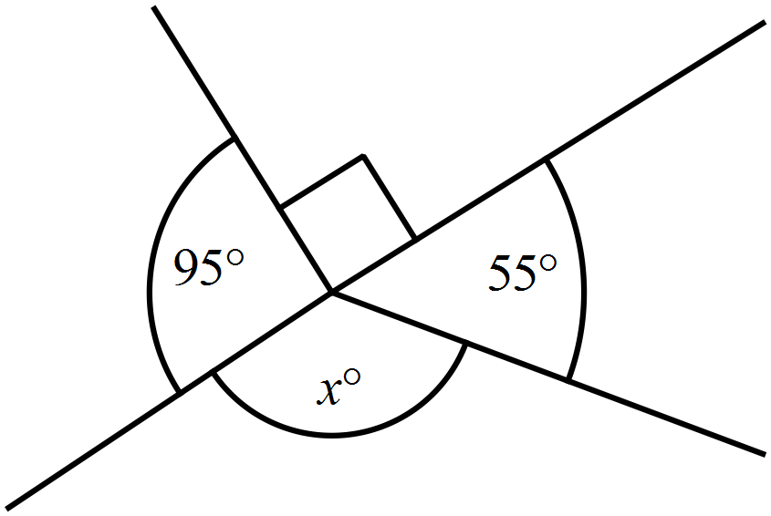What is the value of 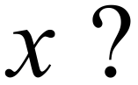  ………………………………………………  ……………………………………………....  ………………………………………………  ……………………………………………….
5. | 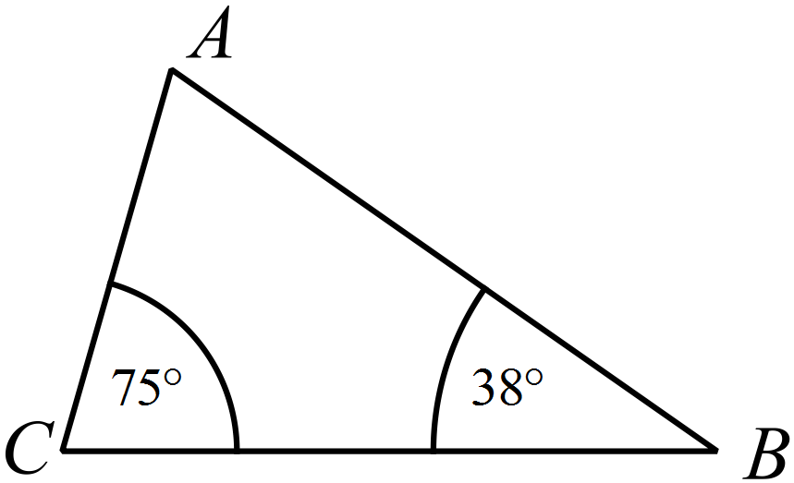What is the size of   ………………………………………………  ……………………………………………....  ………………………………………………  ……………………………………………….
6. |   Rob packs 200 thumb drives which each have a mass of 24 grams into a carton which has a mass of 1.8 kg. What is the mass of the fully packed carton? (Answer in kilograms.)  `  ……………………………………………………………………………………………....  ……………………………………………………………………………………………….
7. | 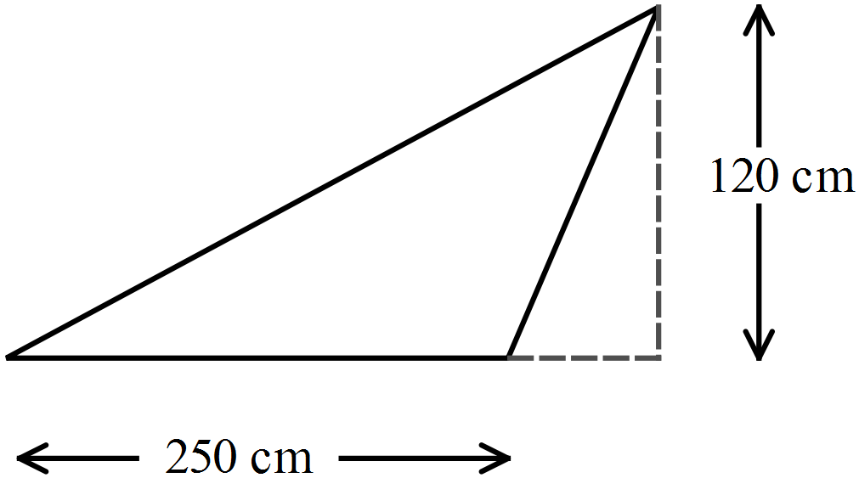What is the area of this triangle?  ………………………………………………  ……………………………………………....  ………………………………………………  ……………………………………………….
8. | 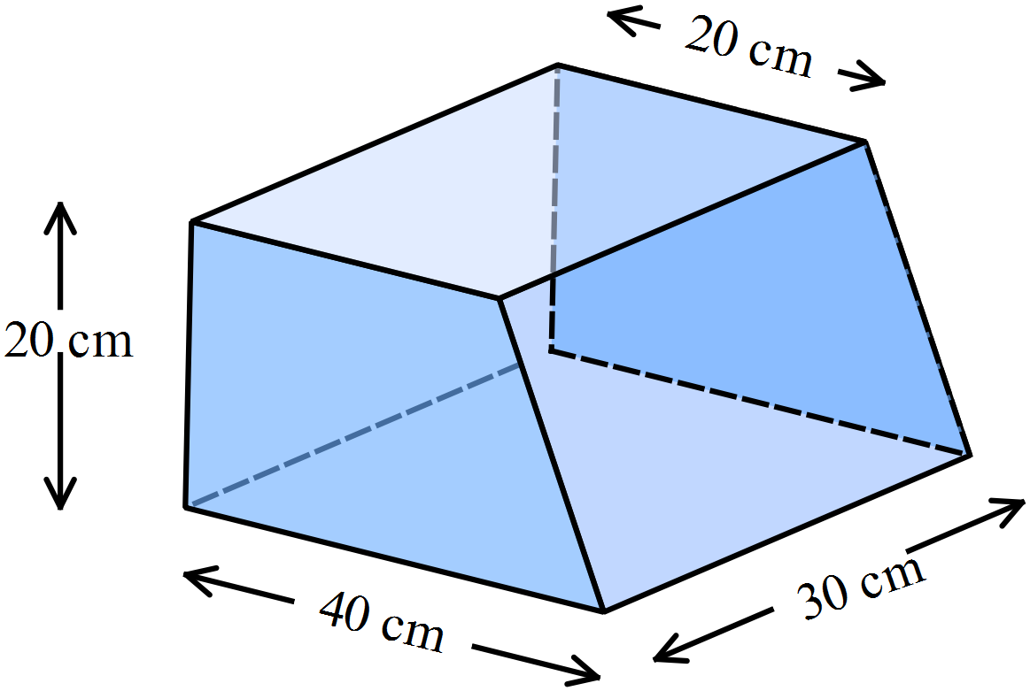What is the volume of this solid?  ………………………………………………  ……………………………………………....  ………………………………………………  ……………………………………………….
9. | 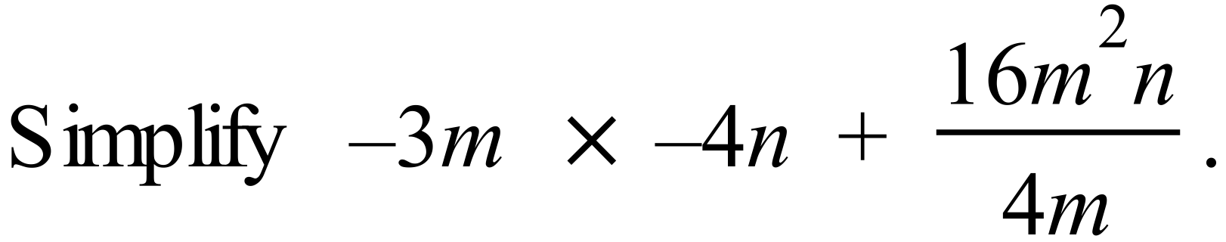  ……………………………………………………………………………………………....  ……………………………………………………………………………………………….
10. | ……………………………………………………………………………………………....  ……………………………………………………………………………………………….
11. | 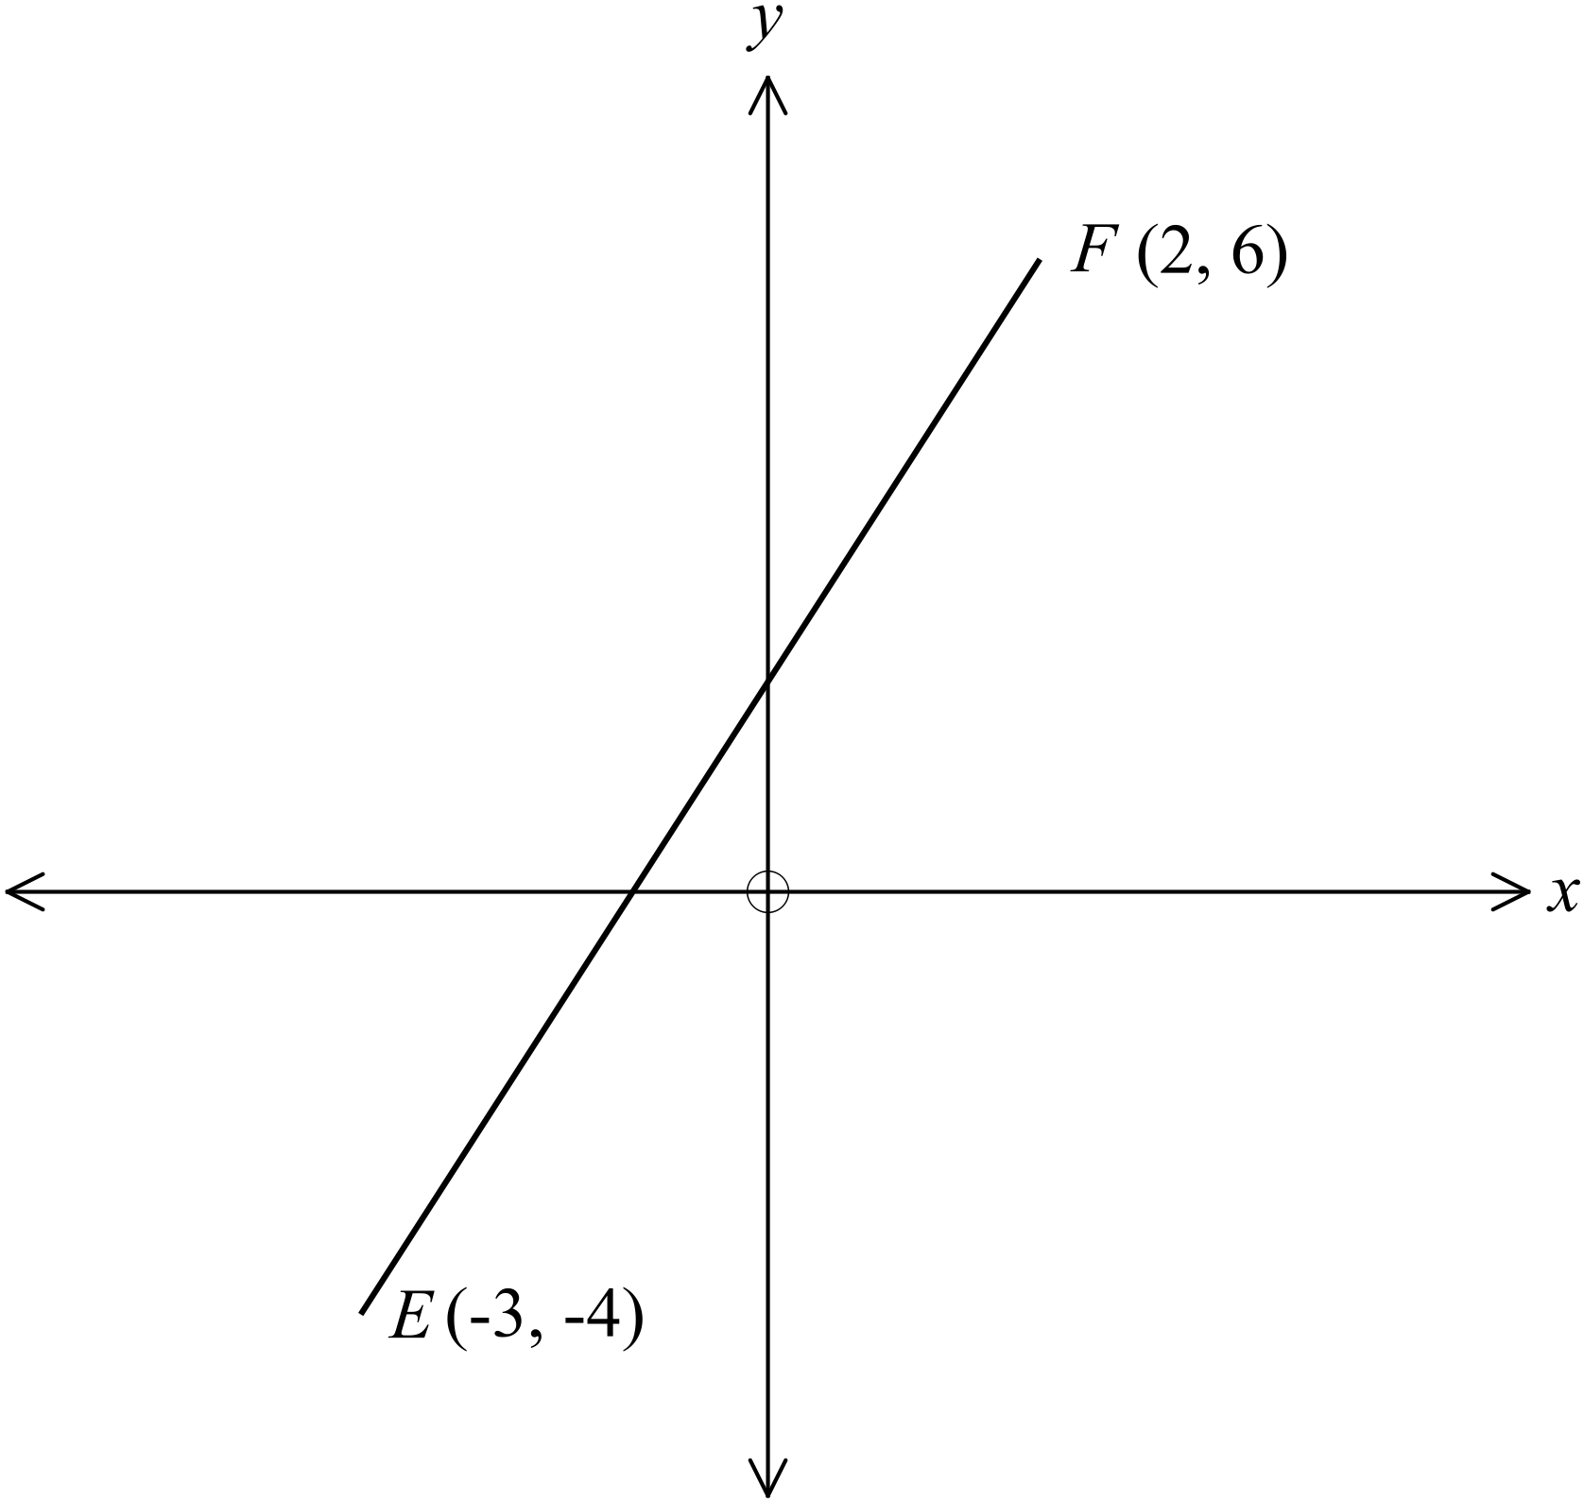What is the gradient of the interval   ………………………………………………  ……………………………………………....  ………………………………………………  ……………………………………………….
12. | 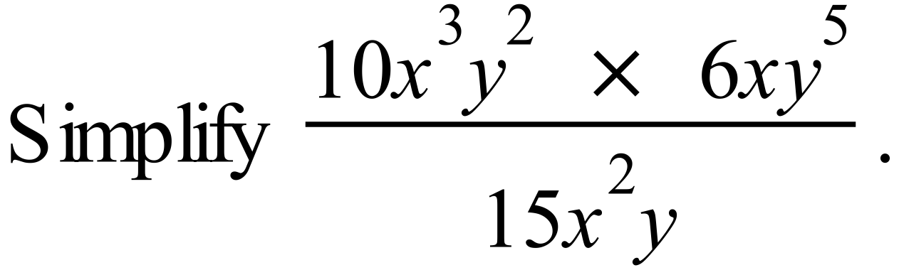  ……………………………………………………………………………………………....  ……………………………………………………………………………………………….
13. | Solve: 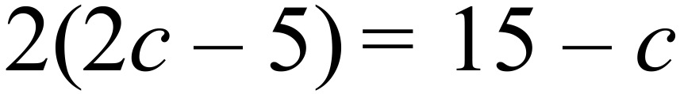.  ……………………………………………………………………………………………....  ……………………………………………………………………………………………….
Questions 14 and 15 refer to the dot plot below.

The plot shows the scores by 20 golfers over a full round of a course.
 |  |  |  |  |  | ⃝
 |  |  |  |  |  | ⃝ | ⃝
 |  |  |  | ⃝ | ⃝ | ⃝ | ⃝
 |  |  | ⃝ | ⃝ | ⃝ | ⃝ | ⃝
 | ⃝ | ⃝ | ⃝ | ⃝ | ⃝ | ⃝ | ⃝ | ⃝
 | 46 | 47 | 48 | 49 | 50 | 51 | 52 | 53

14. | The par for the course is a score of 50.  What percentage of the golfers scored below 50?  ……………………………………………………………………………………………....  ……………………………………………………………………………………………….
15. | What was the median score for the 20 golfers?  ……………………………………………………………………………………………....  ……………………………………………………………………………………………….
16. | Simplify the ratio 12.5 : 50.  ……………………………………………………………………………………………....  ……………………………………………………………………………………………….
17. | 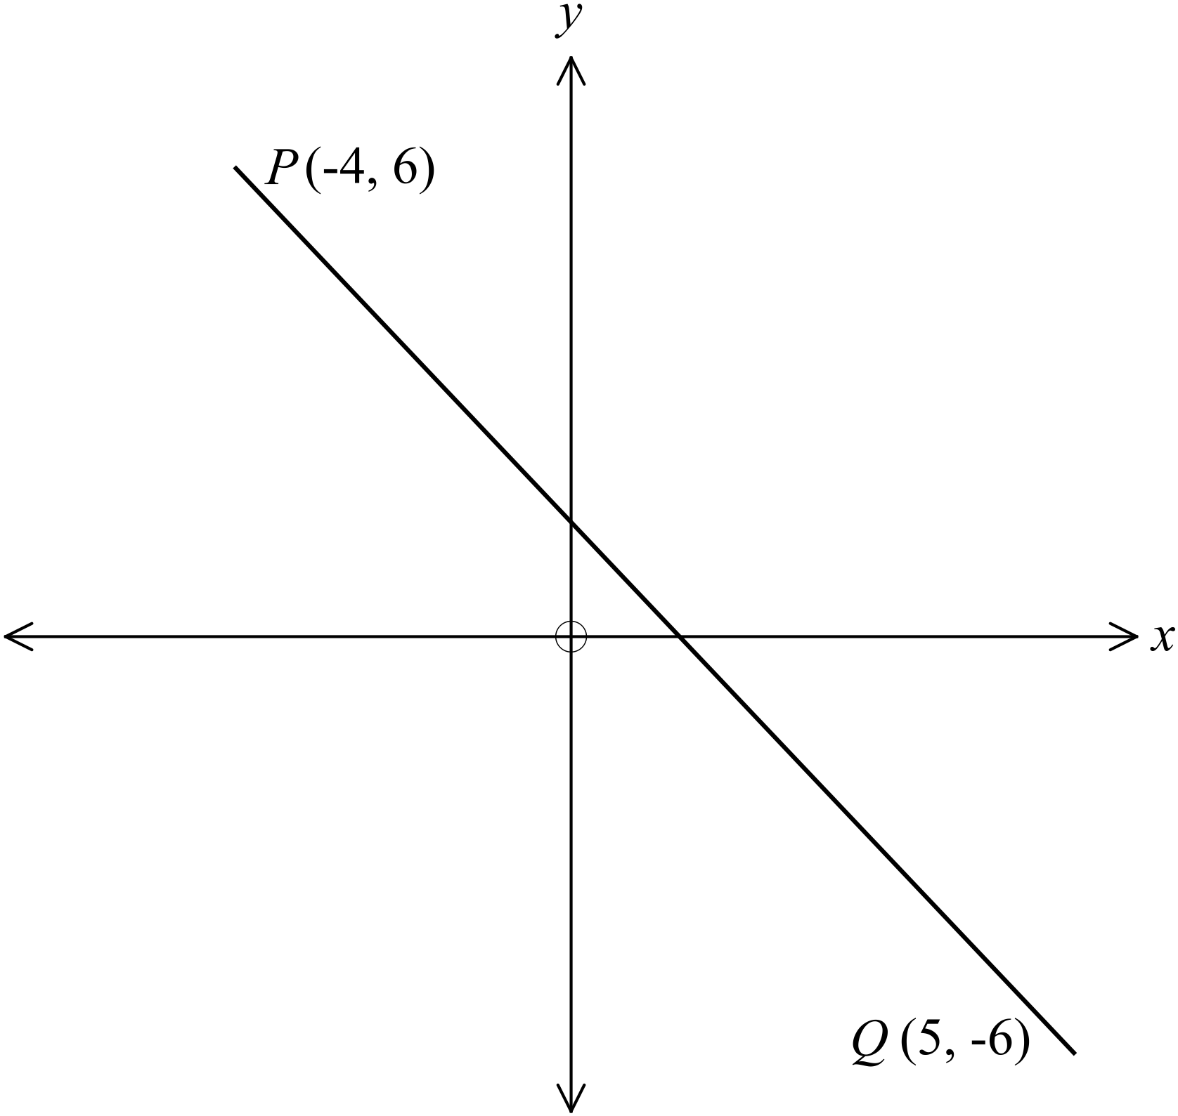What is the length of the interval 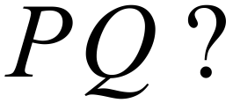  ………………………………………………  ……………………………………………....  ………………………………………………  ……………………………………………….
18. | 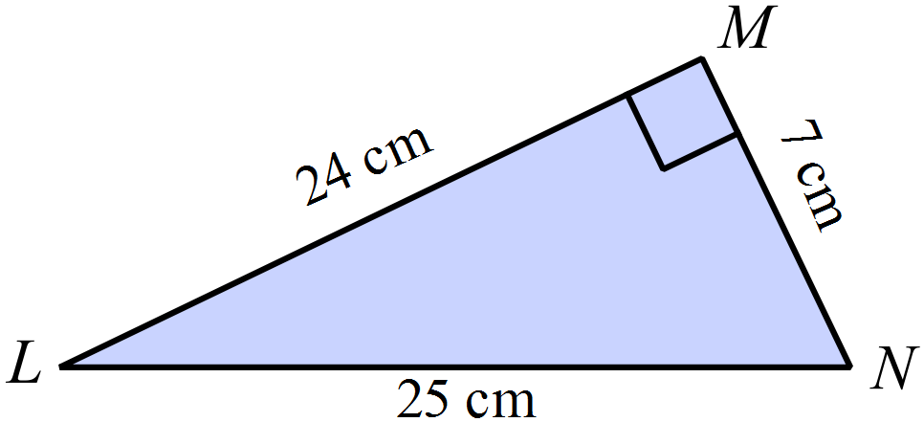What is the value of  in the right triangle shown?  ………………………………………………  ……………………………………………....  ………………………………………………  ……………………………………………….
19. | 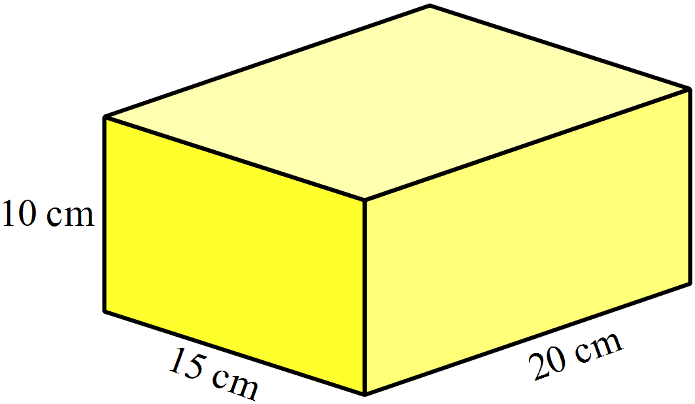Find the surface area of the rectangular prism shown.  ………………………………………………  ……………………………………………....  ………………………………………………  ……………………………………………….
20. | 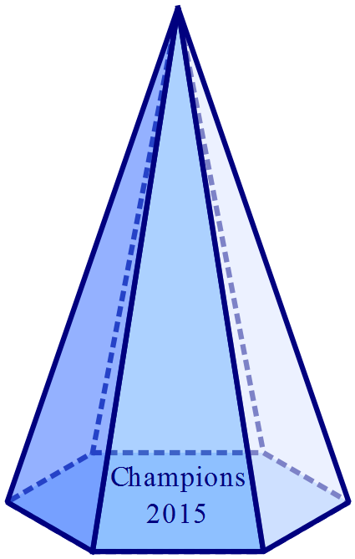A glass pyramid is used as a trophy for a netball competition.  It has a hexagonal base with an area of 30cm² and a perpendicular height of 12 cm.  What volume of glass is used in the trophy?  ……………………………………………....  ………………………………………………  ……………………………………………….
21. | Use geometric instruments to draw a 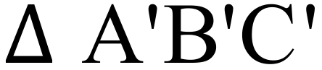 which is congruent to  below, but which has been rotated through 180º about the point D.  The point C’ has been drawn for you.  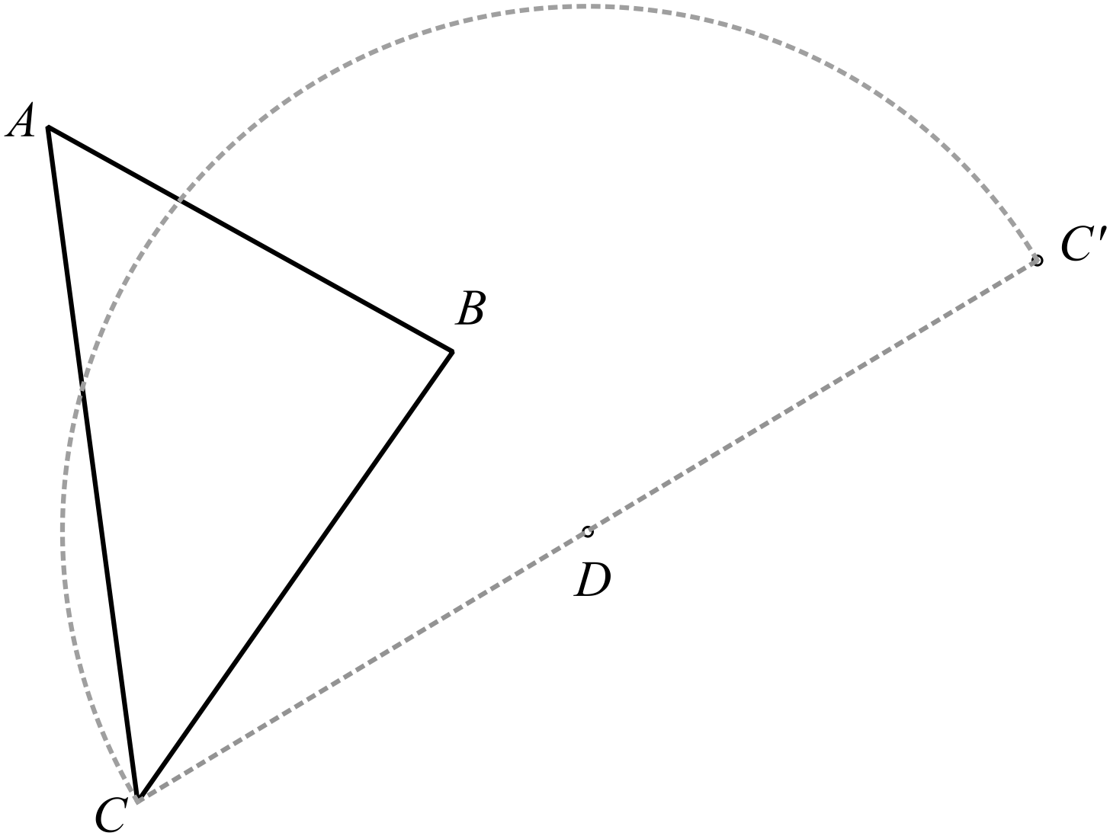Leave all of your construction lines on the diagram.
22. | There are some black, some white and some patterned counters on a table, as shown.  If one counter is picked up at random from the table, which colours are equally likely to be picked up?  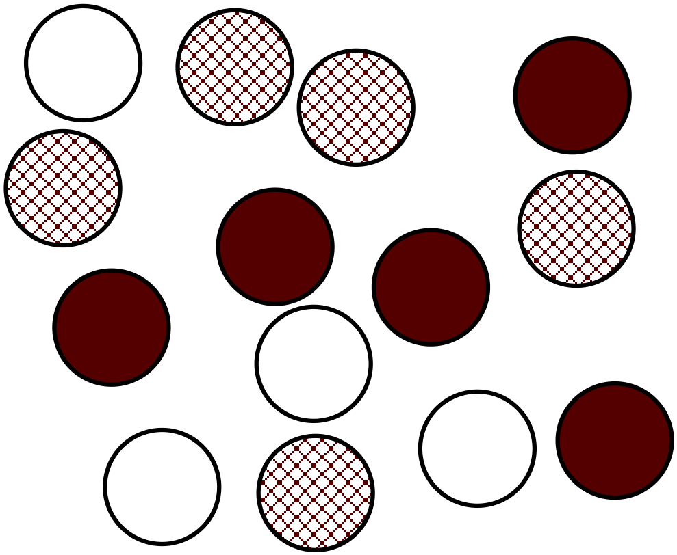  ………………………………………………  ……………………………………………....  ………………………………………………  ……………………………………………….
23. | 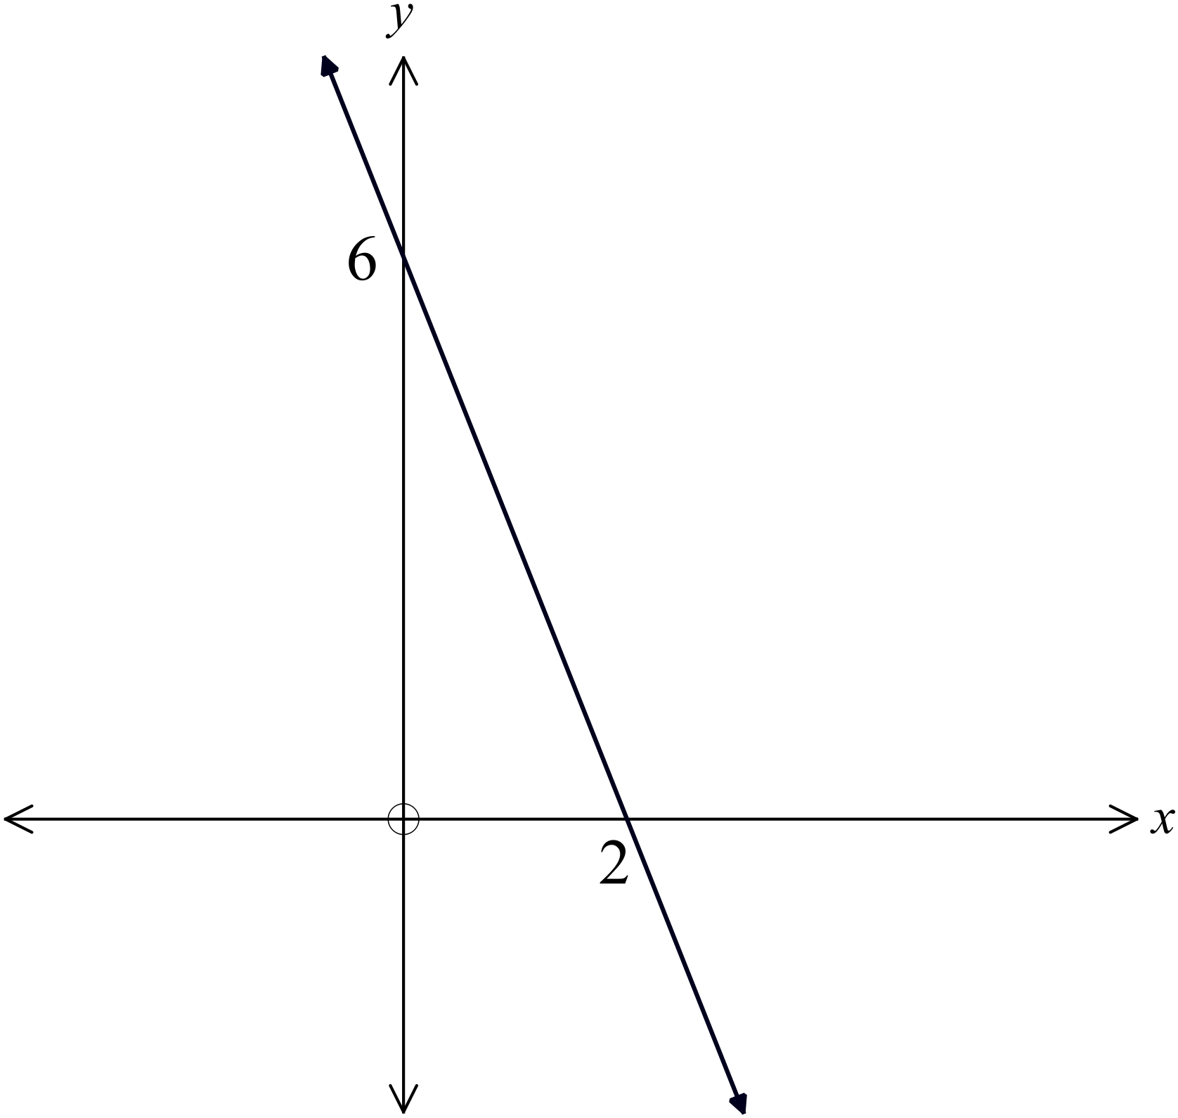What is the equation of the line drawn on the set of axes shown?  ………………………………………………  ……………………………………………....  ………………………………………………  ……………………………………………….
24. | Use the table below to draw a sketch of the curve 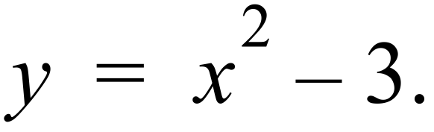  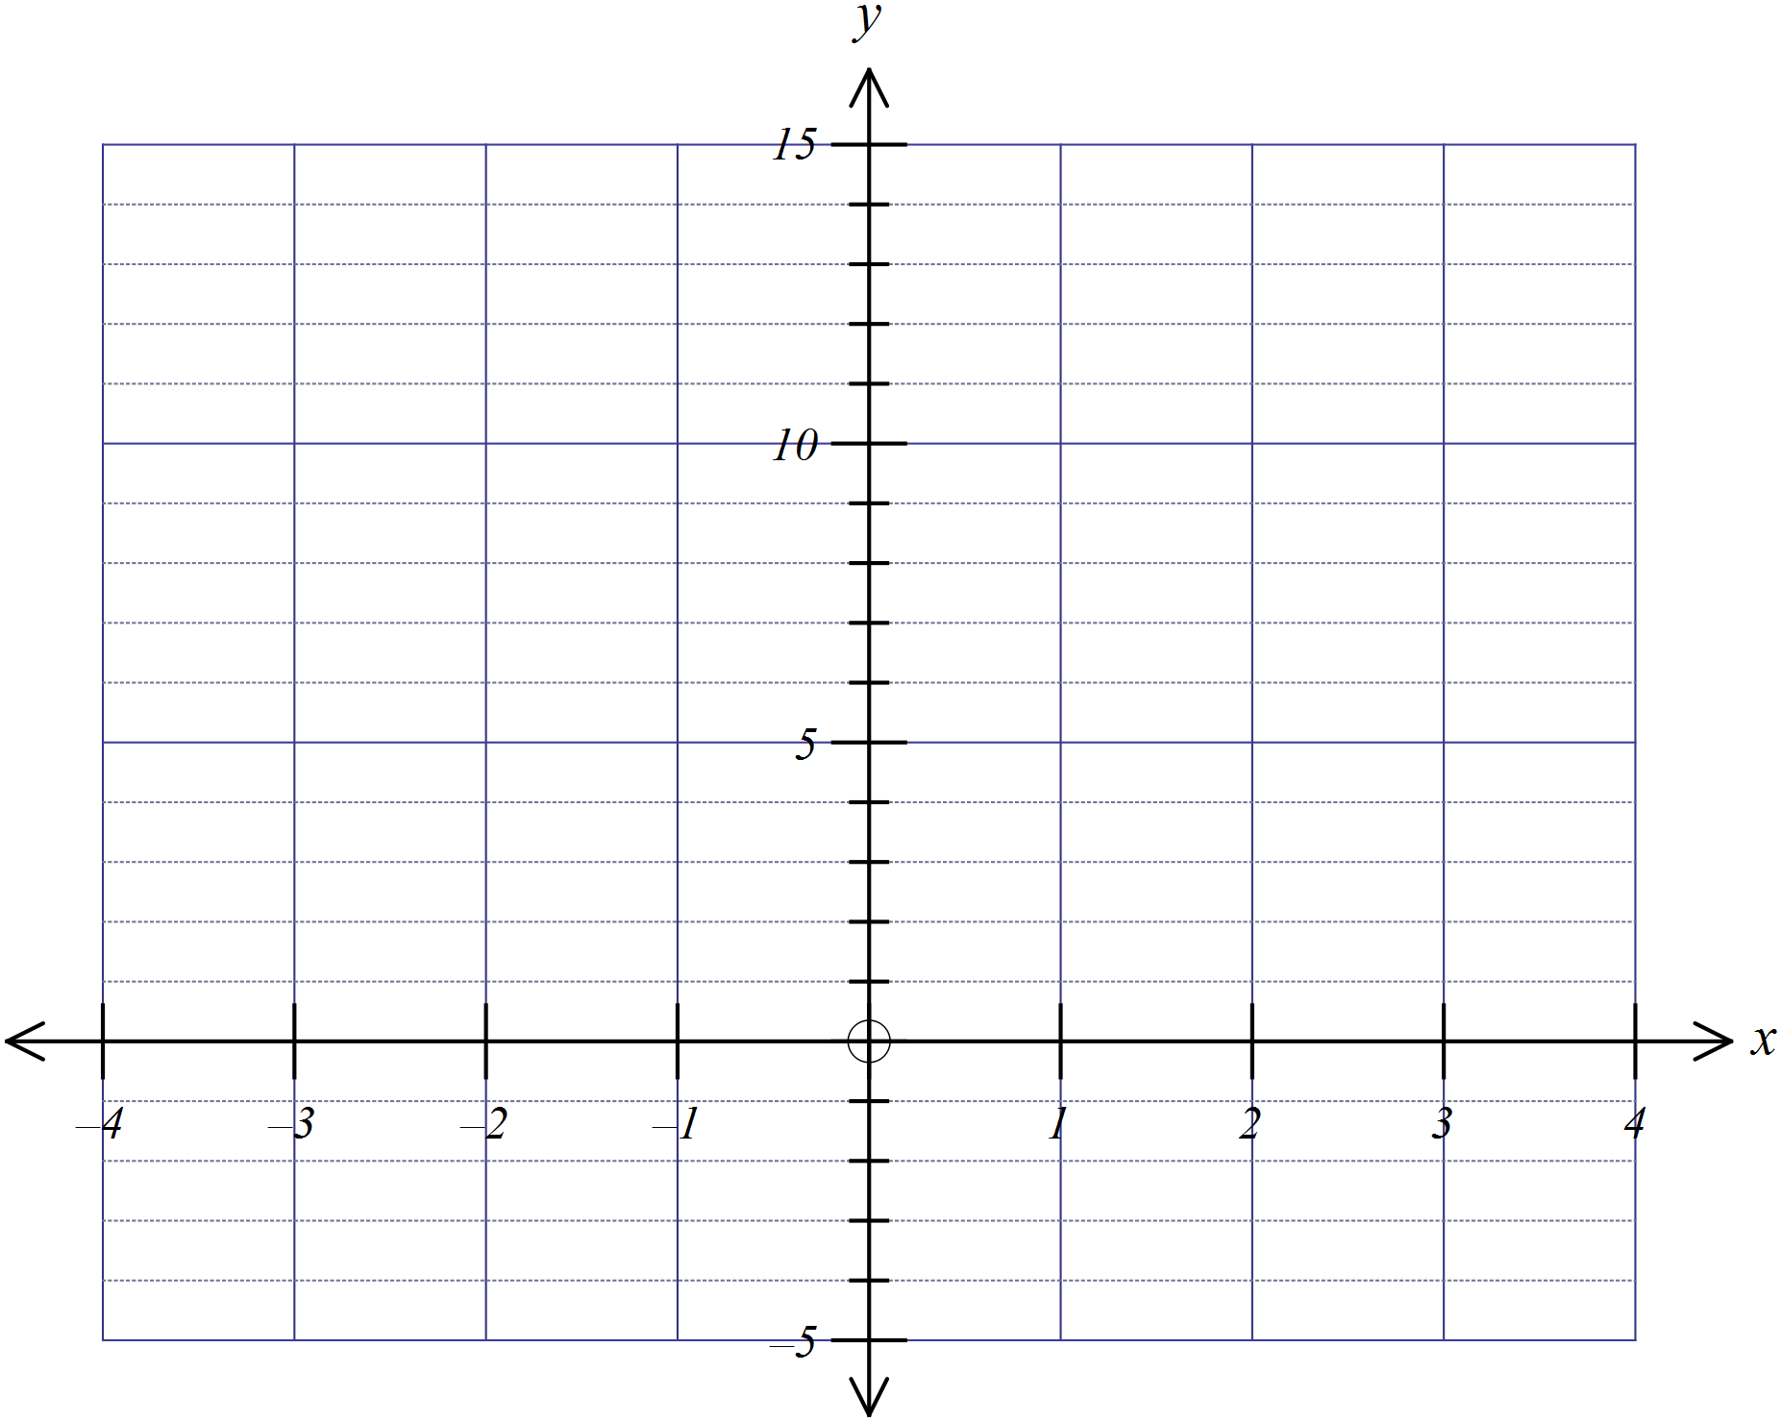
  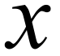 | -4 | -3 | -2 | -1 | 0 | 1 | 2 | 3 | 4
  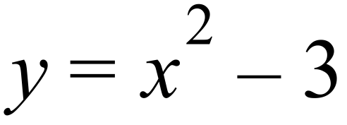 | 13 | 6 | 1 | -2 | -3 | -2 | 1 | 6 | 13
25. | Trapezium A is similar to trapezium B.  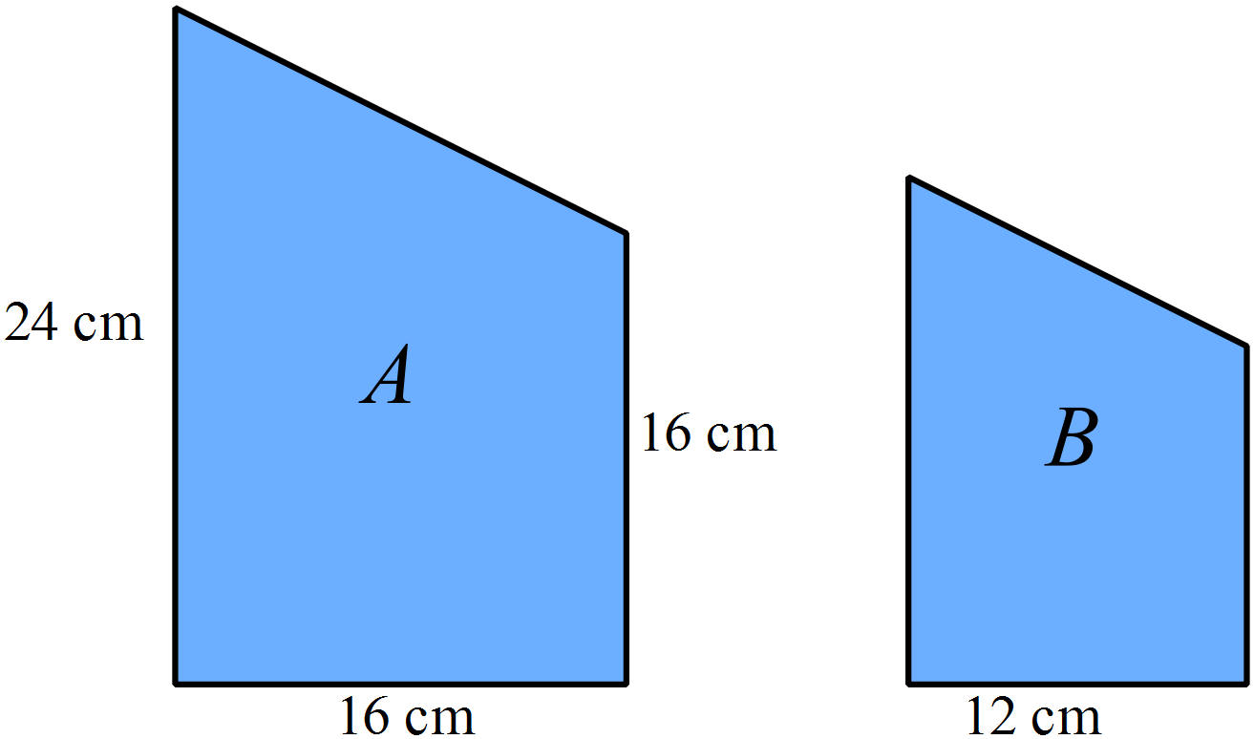  What is the area of trapezium B?  ….…………………………………………………………………………………………....  ……………………………………………………………………………………………….  ….…………………………………………………………………………………………....  ……………………………………………………………………………………………….

School Name
Yearly Examination
Year 10
Advanced Mathematics Course
2015

Section 2

75 marks
Time allowed for this section is
1 hour and 30 minutes

This section has TWO parts

Part A – Fifty multiple-choice questions worth 1 mark each.
Mark your answers on the separate answer sheet provided at the end of the examination.
Part B – Longer answer questions worth a total of 25 marks.
Write all answers and working in the spaces provided on this examination paper.

Calculators may be used in this section.

Do not commence Section 2 until you are instructed to do so.

Use the multiple choice answer sheet at the end of the paper to record your answers.
Completely shade the bubble corresponding to the correct answer for each question.

Which of the following are arranged in ascending order?

A. 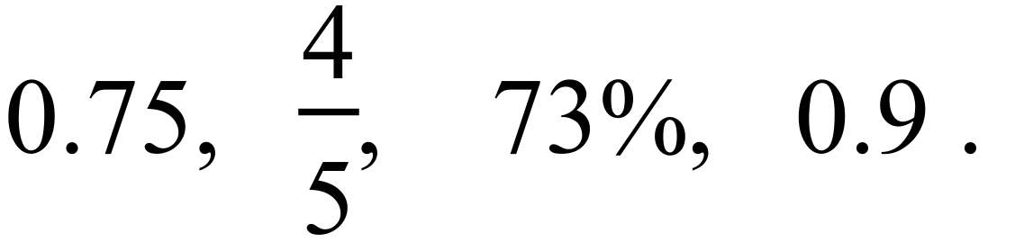
B. 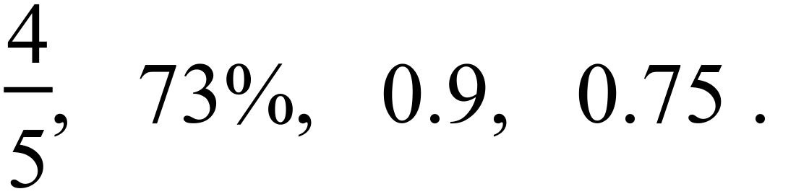
C. 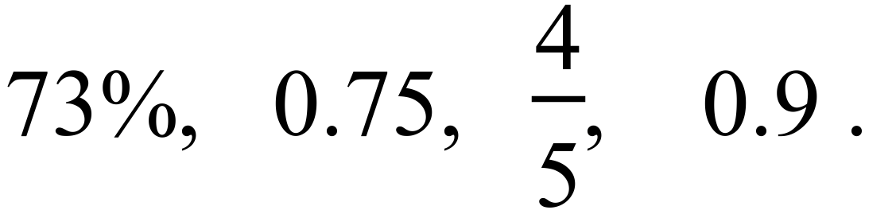
D. 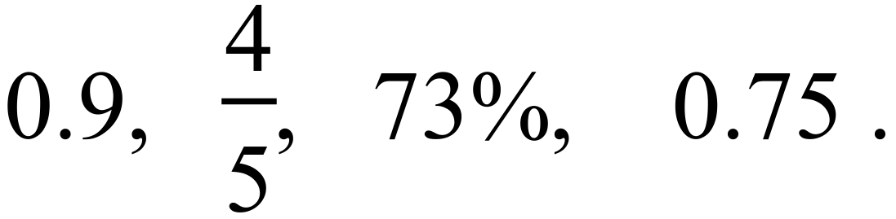
Socrates is paid a normal rate of $48 per hour for a 35 hour week, plus overtime at time and a half after that.
What would he earn for a 43 hour week?

A. $2064 B. $2256 C. $2775 D. $3096
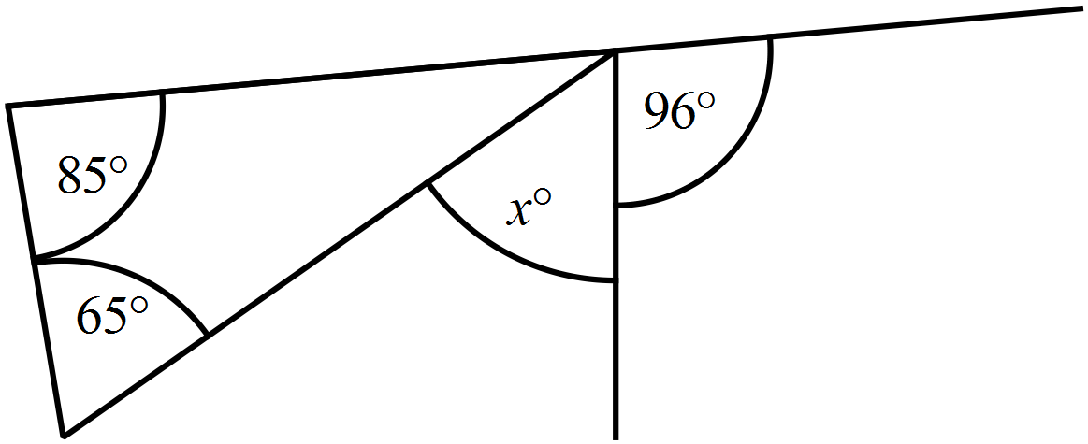What is the value of x?

A. 20º
B. 54º
C. 65º
D. 150º
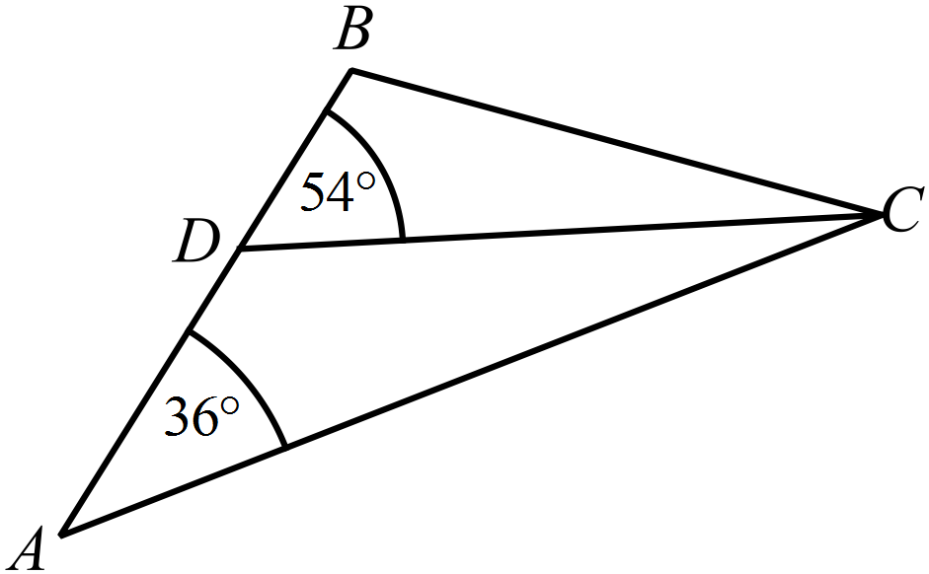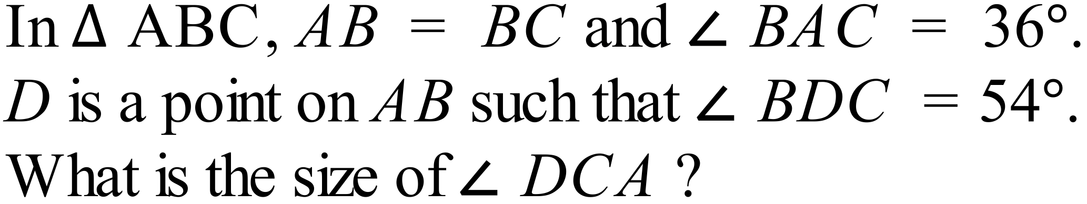

A. 18º
B. 20º
C. 36º
D. 72º
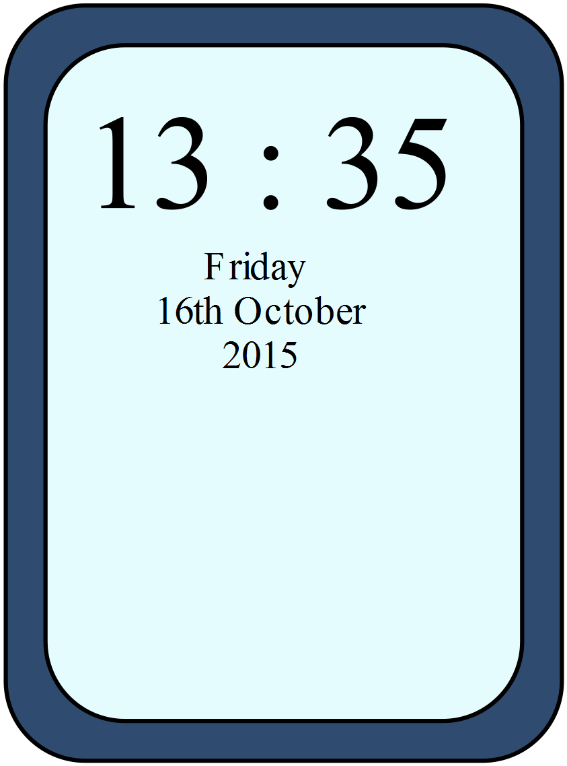Alan checks his phone and sees the time shown.
He has arranged to meet Fiona at a quarter past four that afternoon.
How long does he have till the meeting?
A. An hour and twenty minutes.
B. An hour and forty minutes.
C. Two hours and twenty minutes.
D. Two hours and forty minutes.
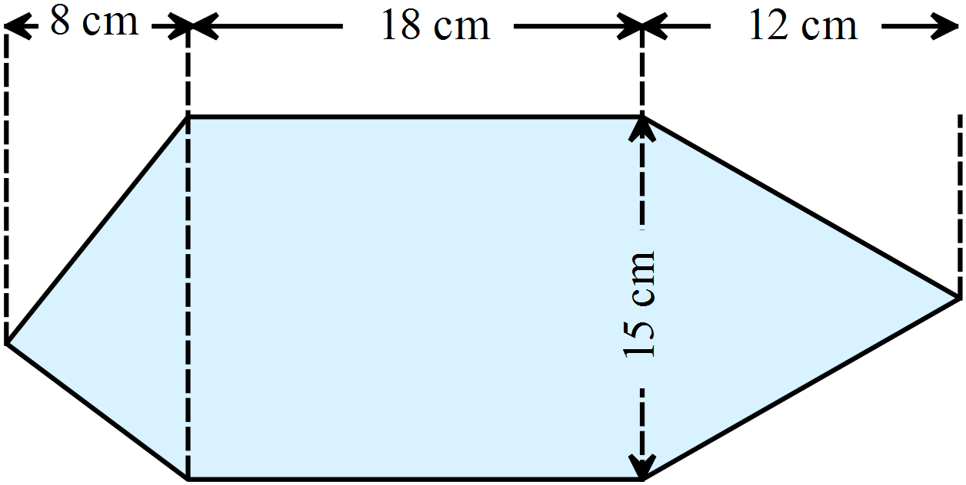What is the area of this shape?

A. 285 cm²
B. 320 cm²
C. 420 cm²
D. 510 cm²

Evaluate 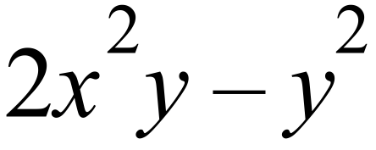 given 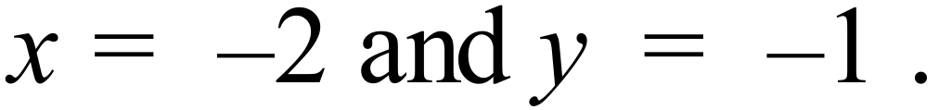

A. 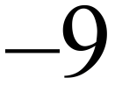 B. 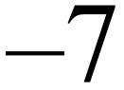 C. 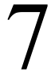 D. 9
Simplify 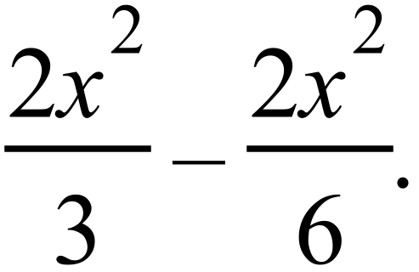

A. 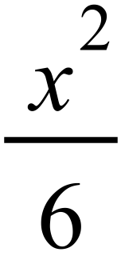 B. 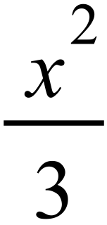 C. 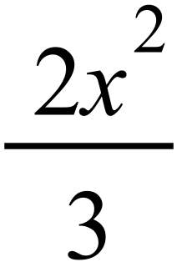 D. 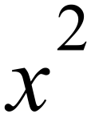
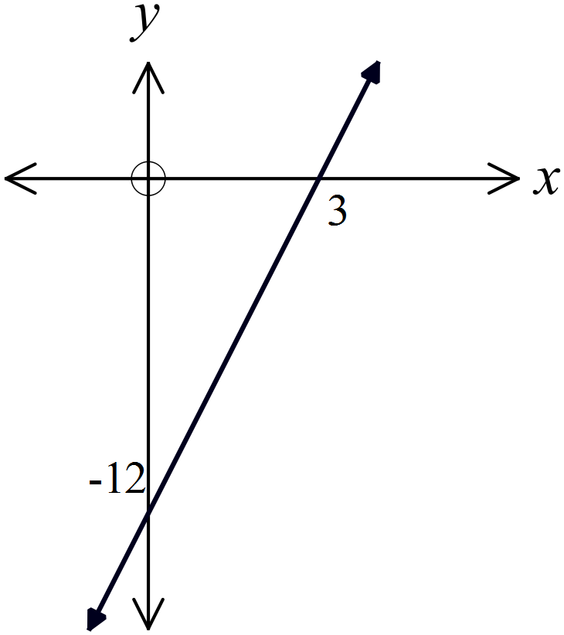What is the equation of this line?

A. 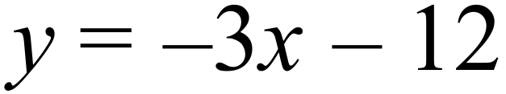
B. 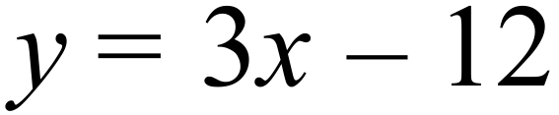
C. 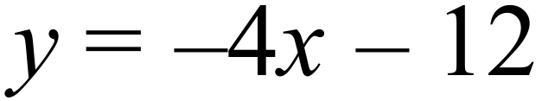
D. 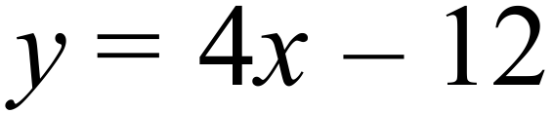

At its furthest, Pluto is 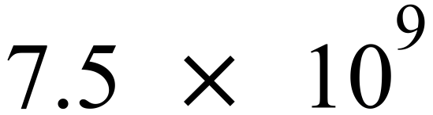 km from the Earth.
This can also be written as :
A. 75 000 000 km
B. 750 000 000 km
C. 7 500 000 000 km
D. 75 000 000 000 km
Which graph shows the solution to 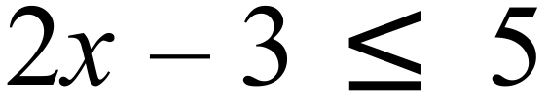 ?
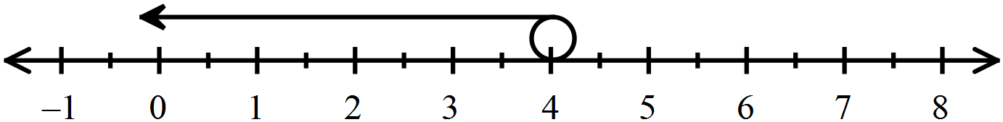
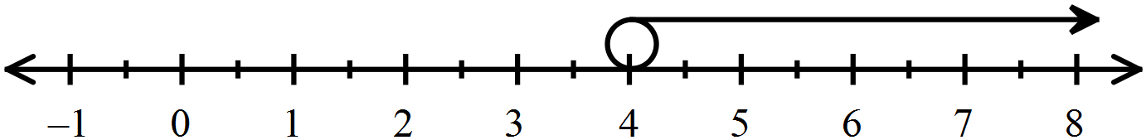 A.
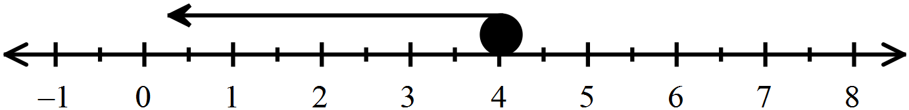 B.
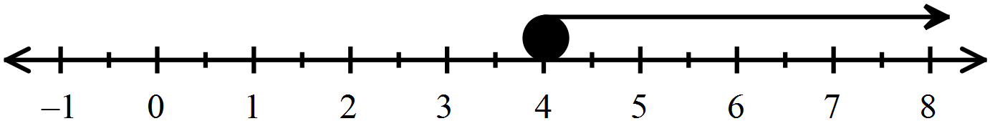 C.
D.

Questions 37 – 39 refer to the following.
The stem and leaf plot below shows the number of points scored by players in a single end of an outdoor archery tournament.

 | 2 | 2 | 8
 | 3 | 7 | 9
 | 4 | 5 | 7 | 8 | 8 | 8 | 8
 | 5 | 2 | 4 | 5 | 5 | 7 | 7 | 8 | 8 | 9
 | 6 | 0

What type of data is shown in the plot?

A. Categorical data.
B. Continuous numerical data.
C. Discrete numerical data.
D. Randomly generated data.
What is the interquartile range of the data?

A. 7 B. 11 C. 13 D. 38
If one archer’s score is chosen at random from this end, what is the probability that it is less than 56?

A. 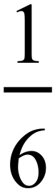 B. 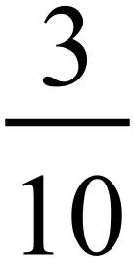 C. 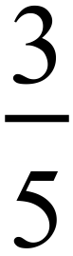 D. 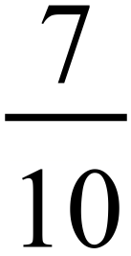
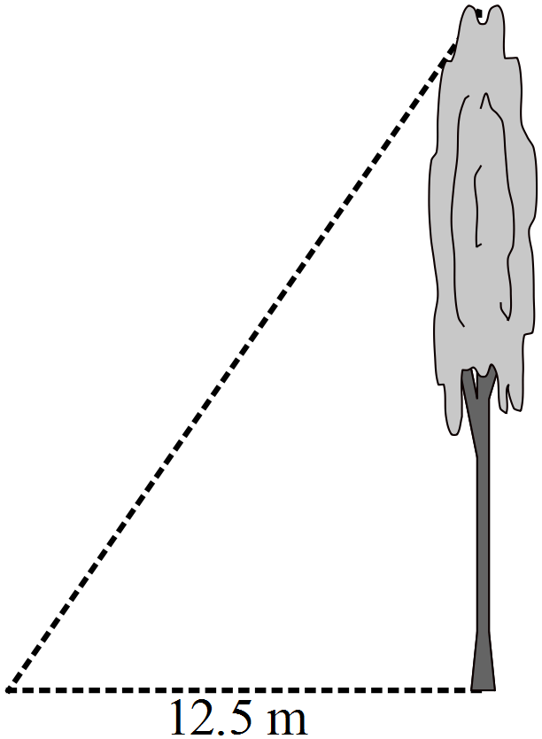From a point on level ground, 12.5 metres from the base of the tree, the angle of elevation of the top of the tree is 63º.
What is the height of the tree, to the nearest tenth of a metre?

A. 5.7 m
B. 6.4 m
C. 15.8 m
D. 24.5 m
Three towns A, B and C lie on the same flat plain.
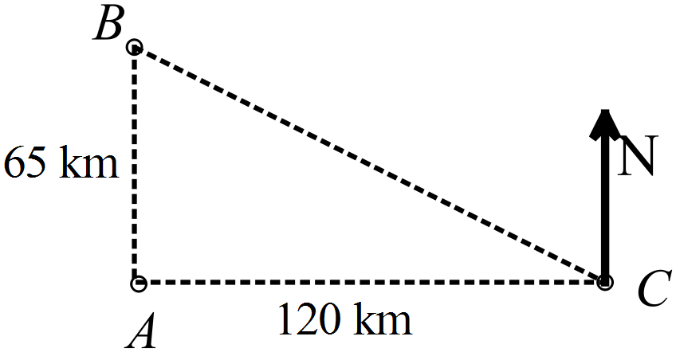A is 65 km due south of B.
C is 120 km due east of A.
What is the bearing of B from C?

A. 028º
B. 118º
C. 242º
D. 298º
Tim bought a set of tradesman’s tools for $3500 four years ago.
What is the value of the set now, if it depreciated at 24% pa?

A. $1167.68 B. $1536.42 C. $2540.00 D. $2660.00

A jet ski can travel at 120 km/h in a straight line.
At this speed how long would it take to travel between two markers that are 900 m apart?

A. 27 seconds B. 30 seconds
C. 36 seconds D. 48 seconds
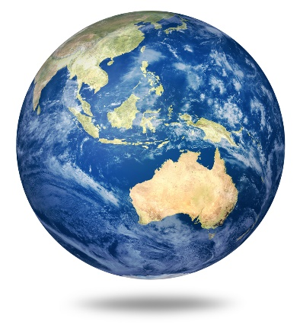
A model of the earth is made from polystyrene.
It is a sphere with a diameter of 2.4 metres.
What volume of polystyrene is needed?

A. 7.2 m³
B. 18.1 m³
C. 57.9 m³
D. 72.4 m³
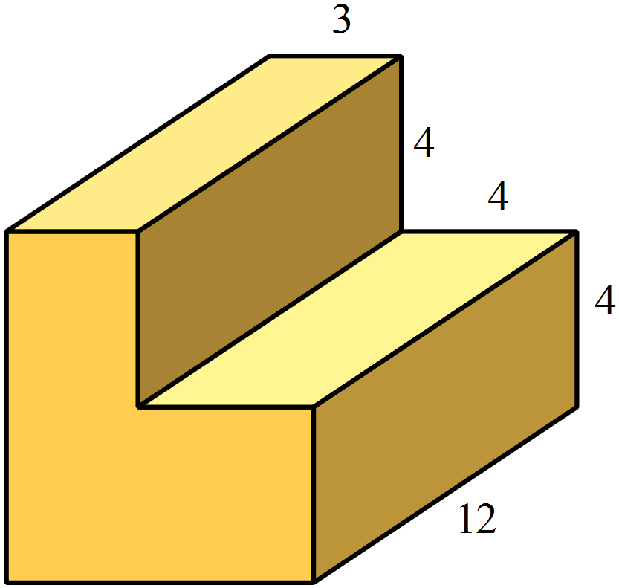In this prism, all angles are right angles and all measurements given are in cm.
What is the surface area of the prism?

A. 400 m²
B. 440 m²
C. 480 m²
D. 520 m²

The box plot shows the scores by contestant on a quiz.
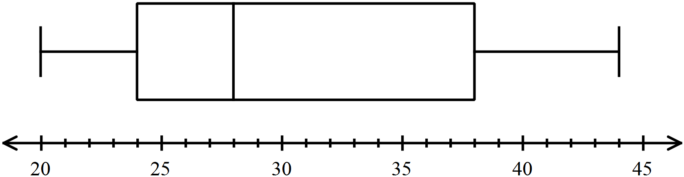

What percentage of the scores lie between 24 and 44?

A. 25% B. 50% C. 66% D. 75%
Which pair of lines are parallel?

A.
B.
C.
D. 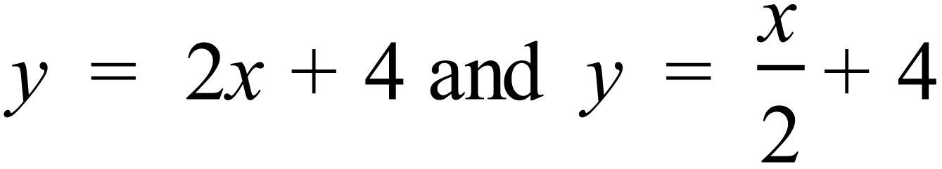
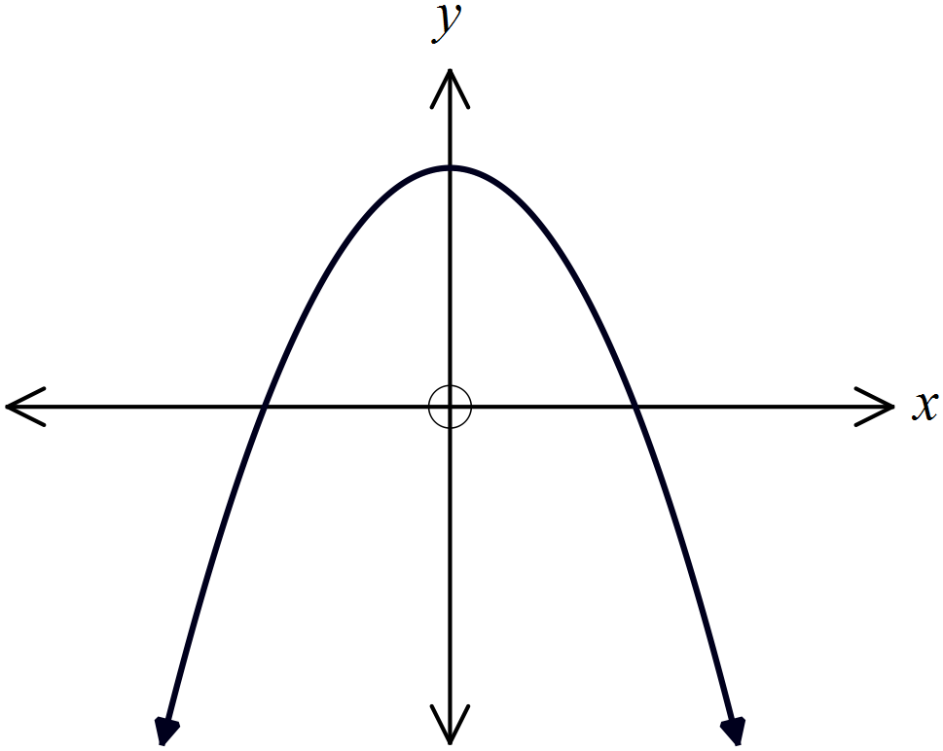Which of these equations could describe this graph?

A. 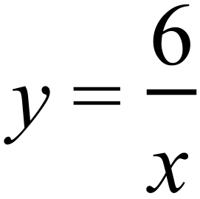
B. 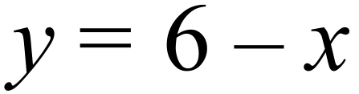
C. 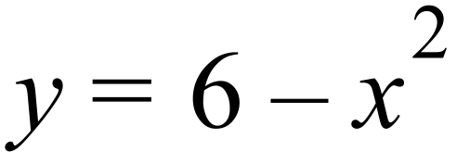
D. 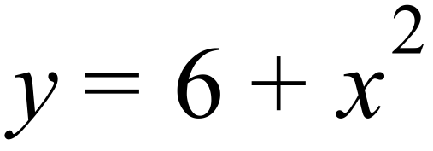

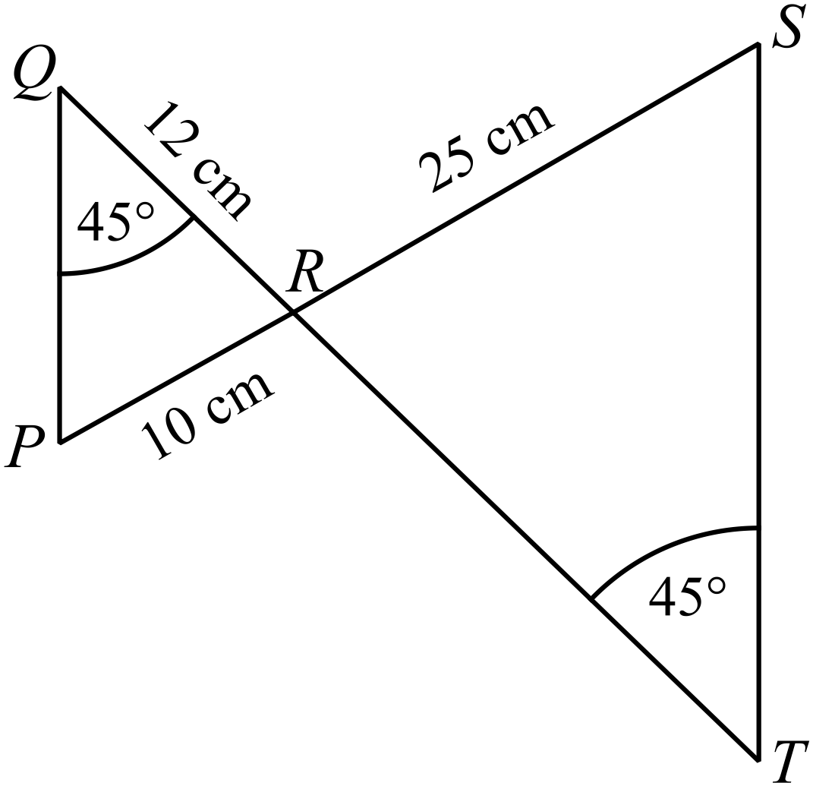In the diagram 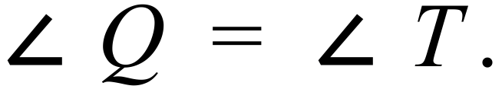
What is the length of TR (correct to 1 d.p.)?

A. 20.8 cm
B. 30.0 cm
C. 48.0 cm
D. 60.0 cm

Which of these scatterplots indicates a strong positive relationship between two variables?

A. B.
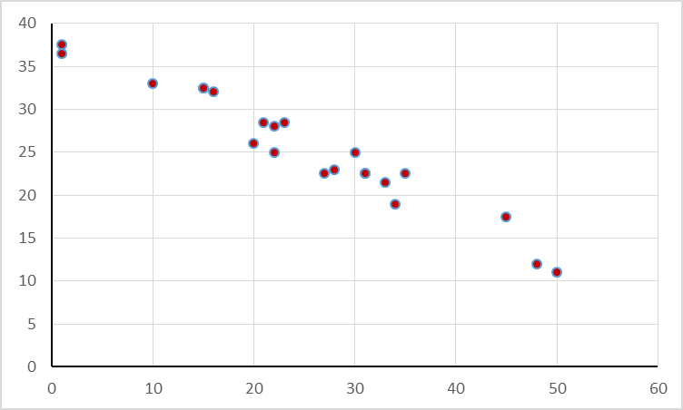
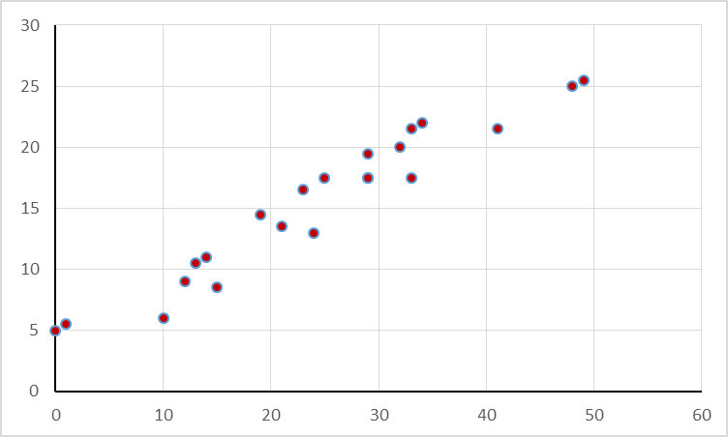

C. D.
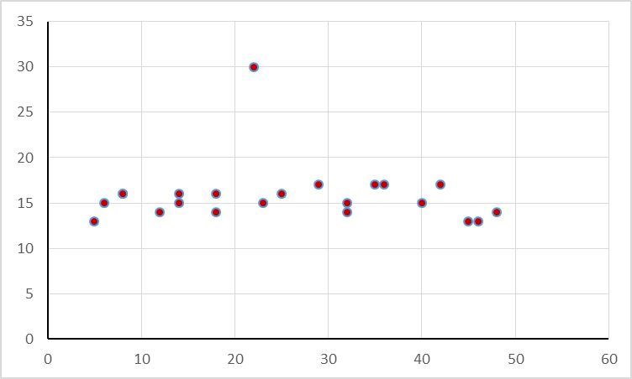
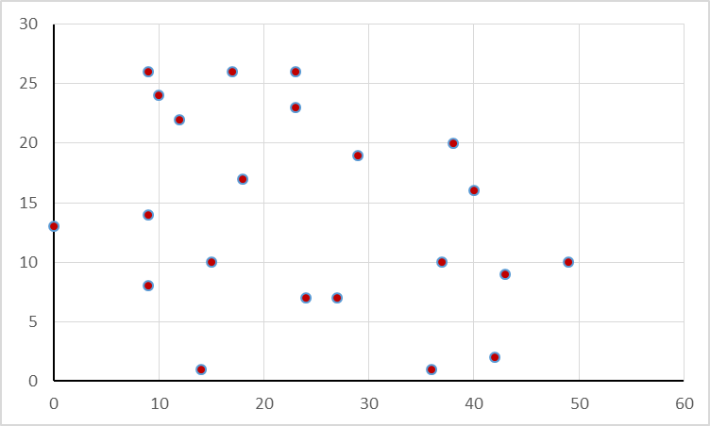

Which of the lines below is perpendicular to 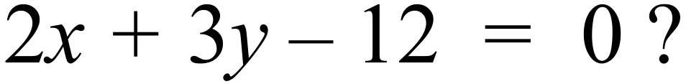

A. 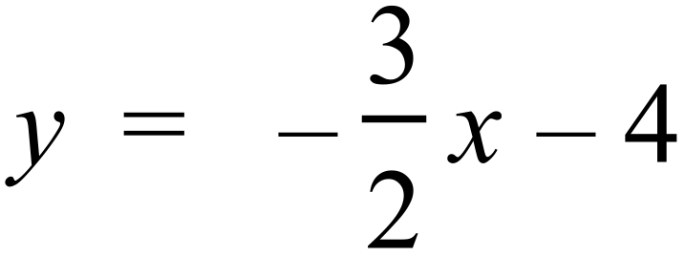
B. 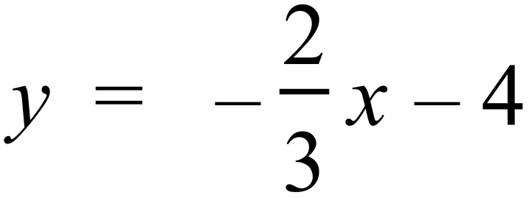
C. 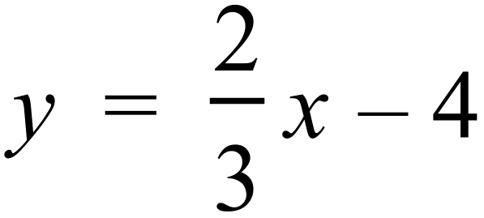
D. 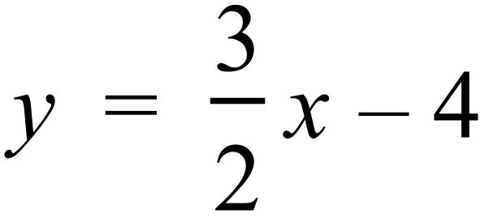
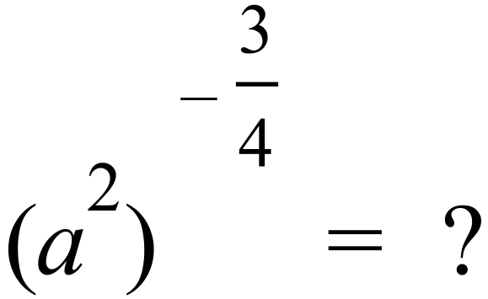

A. 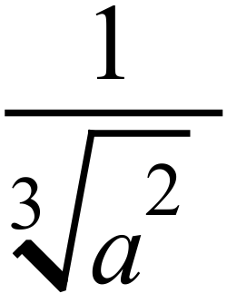 B. 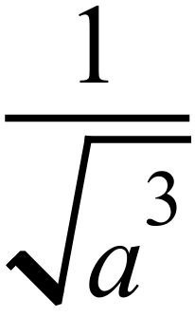 C. 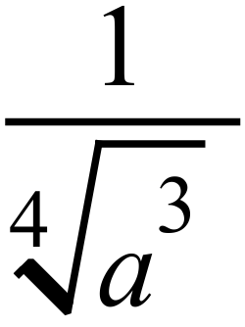 D. 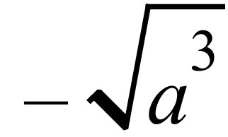
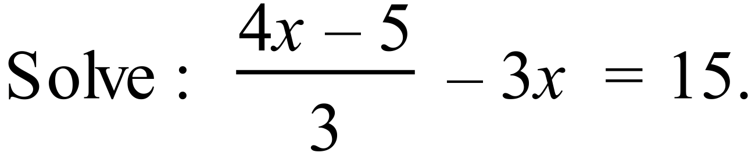

A. 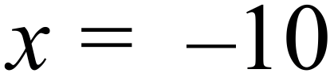 B. 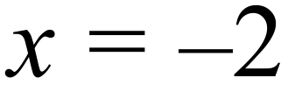 C. 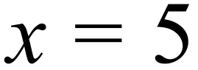 D. 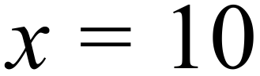
Sharon achieves the following scores in 9 rounds of a gymnastics competition.
8.5, 7.9, 9.4, 8.6, 7.4, 9.5, 6.8, 7.8, 9.2
Which is a correct analysis of her scores, to 1 decimal place?

A. Mean =8.3 and Standard deviation = 0.9.
B. Mean =8.3 and Standard deviation = 1.7.
C. Mean =8.5 and Standard deviation = 0.9.
D. Mean =8.5 and Standard deviation = 1.7.

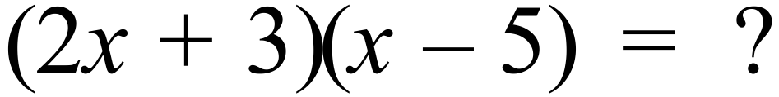

A. 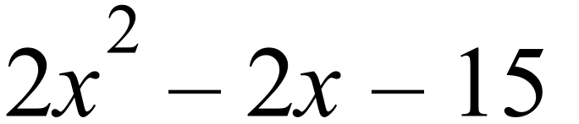 B. 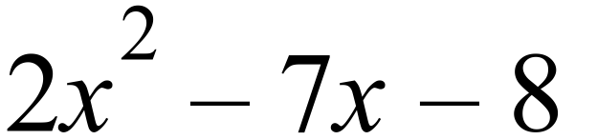
C. 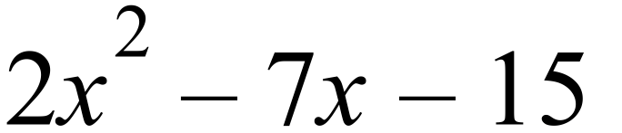 D. 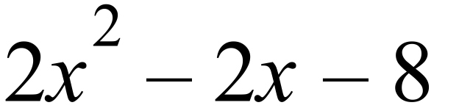
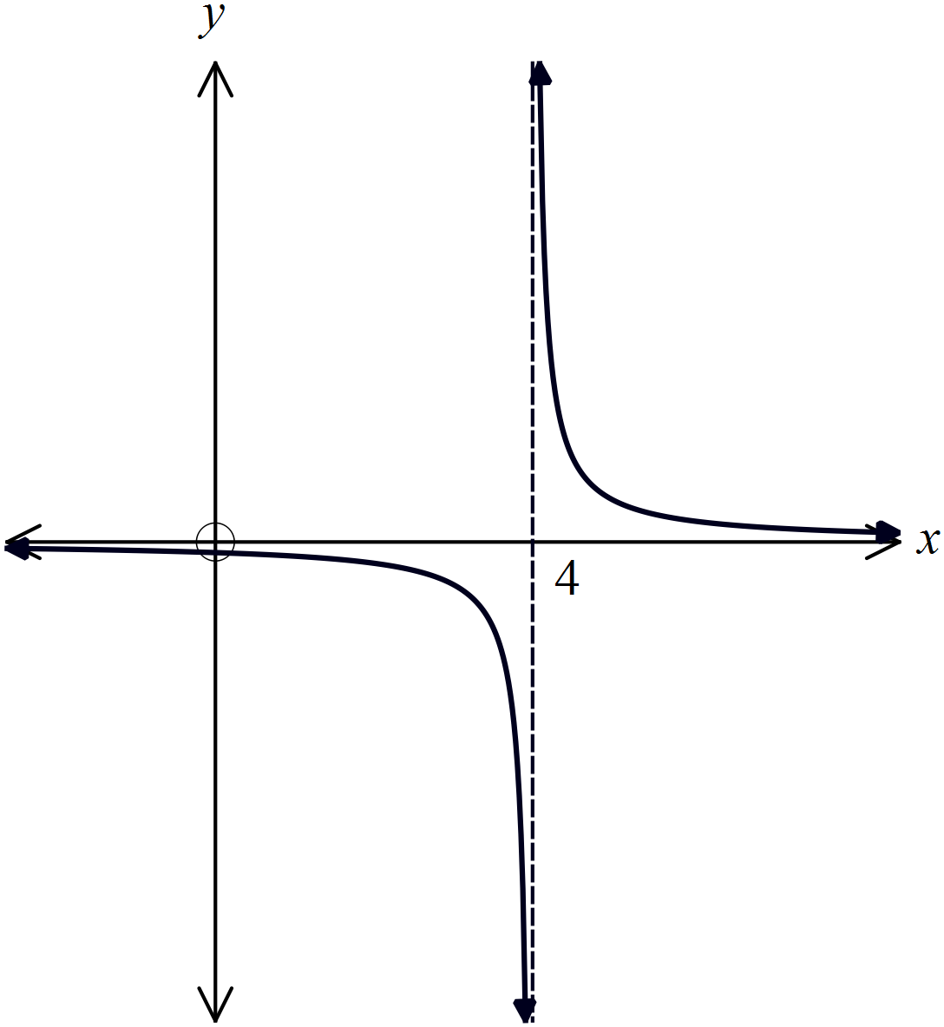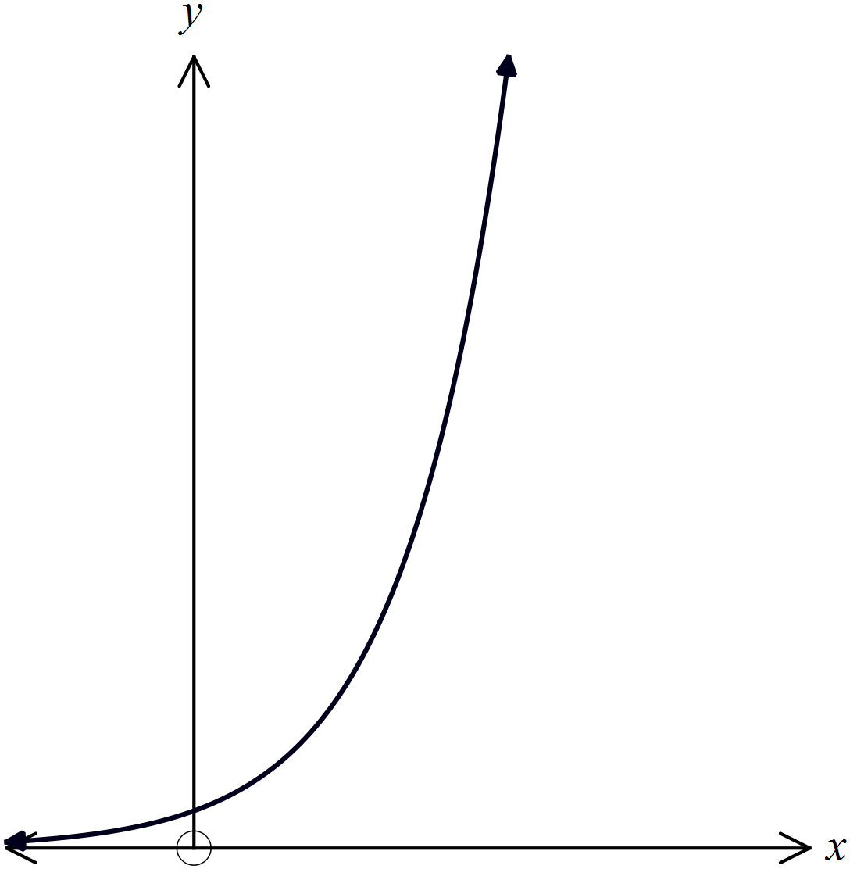Which graph represents the equation 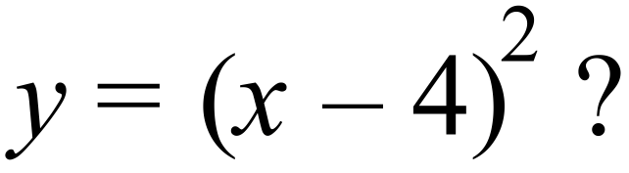
A. B.

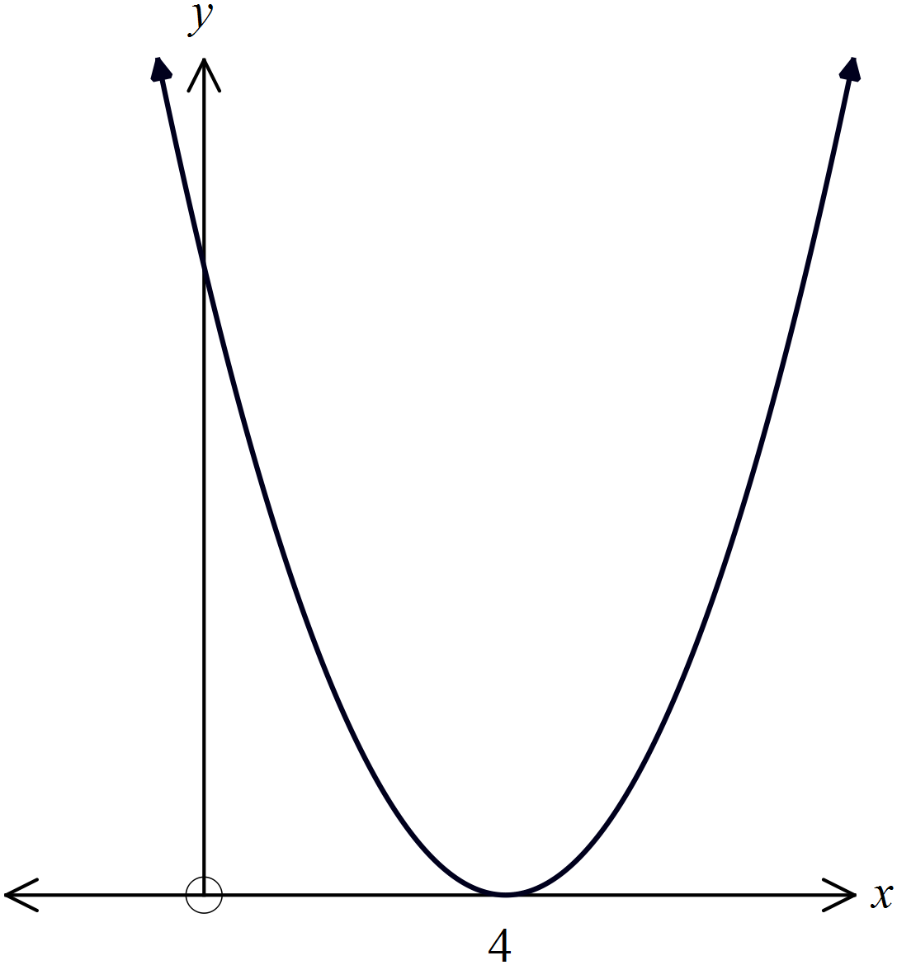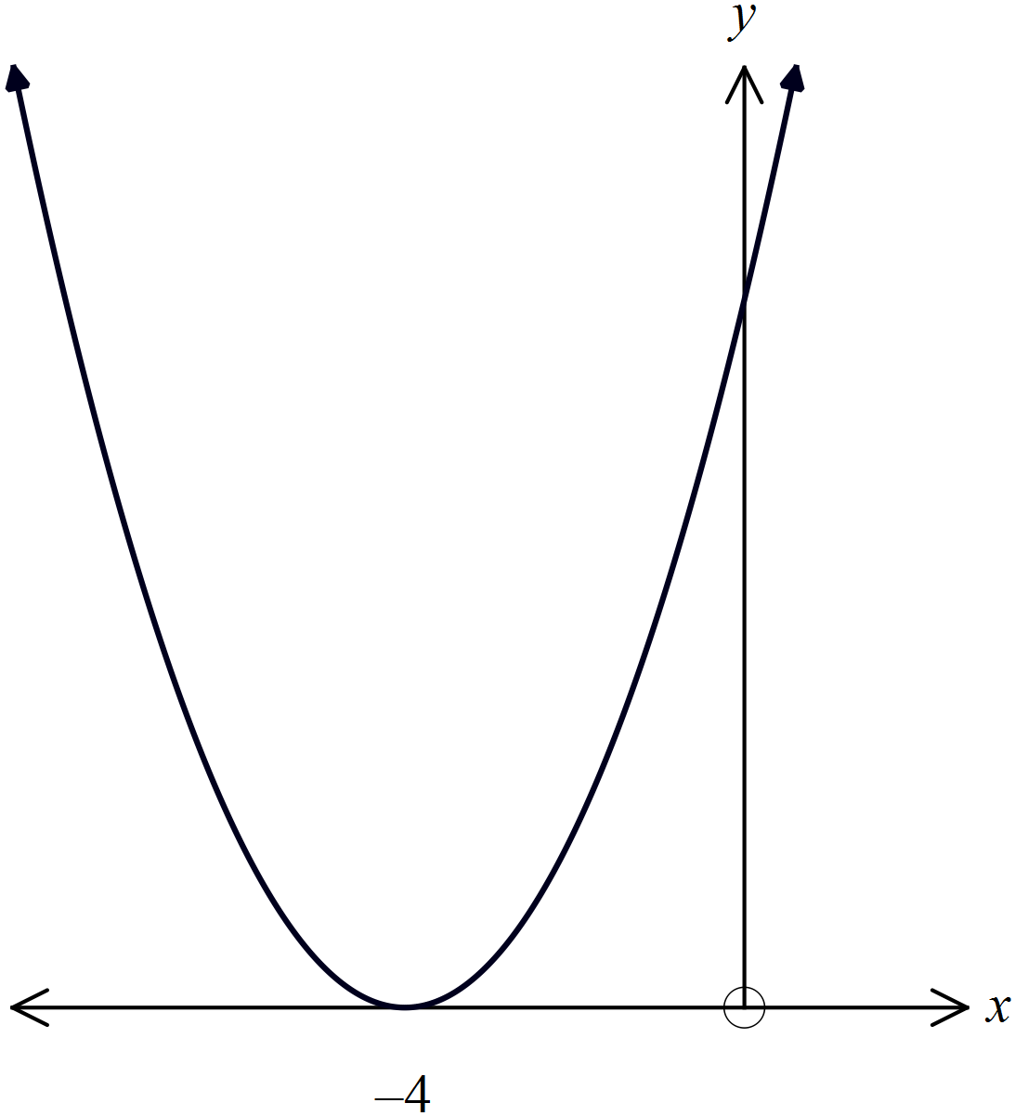 C. D.

Solve 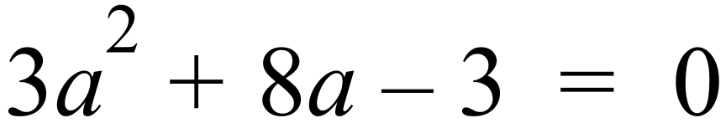

A. 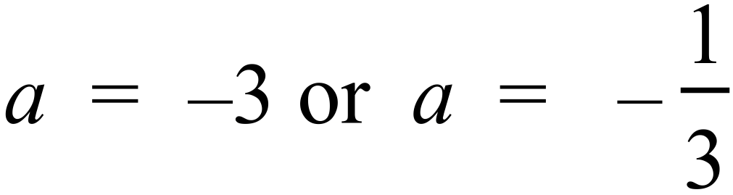 B. 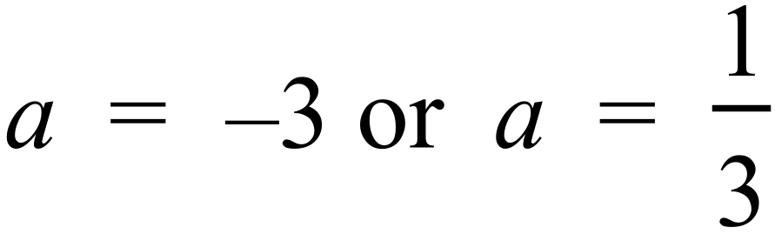
C. 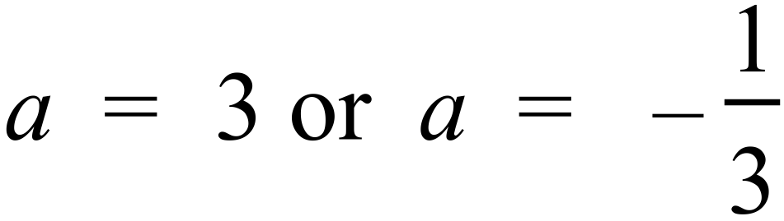 D. 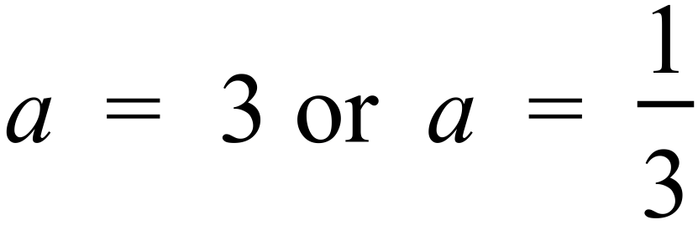
What is the point which simultaneously solves,

A. 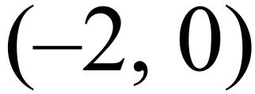 B. 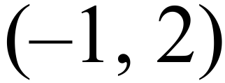 C. 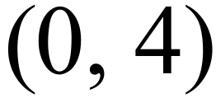 D. ( 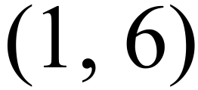
Water is poured at a constant rate into a vase which is a prism with the cross section shown.
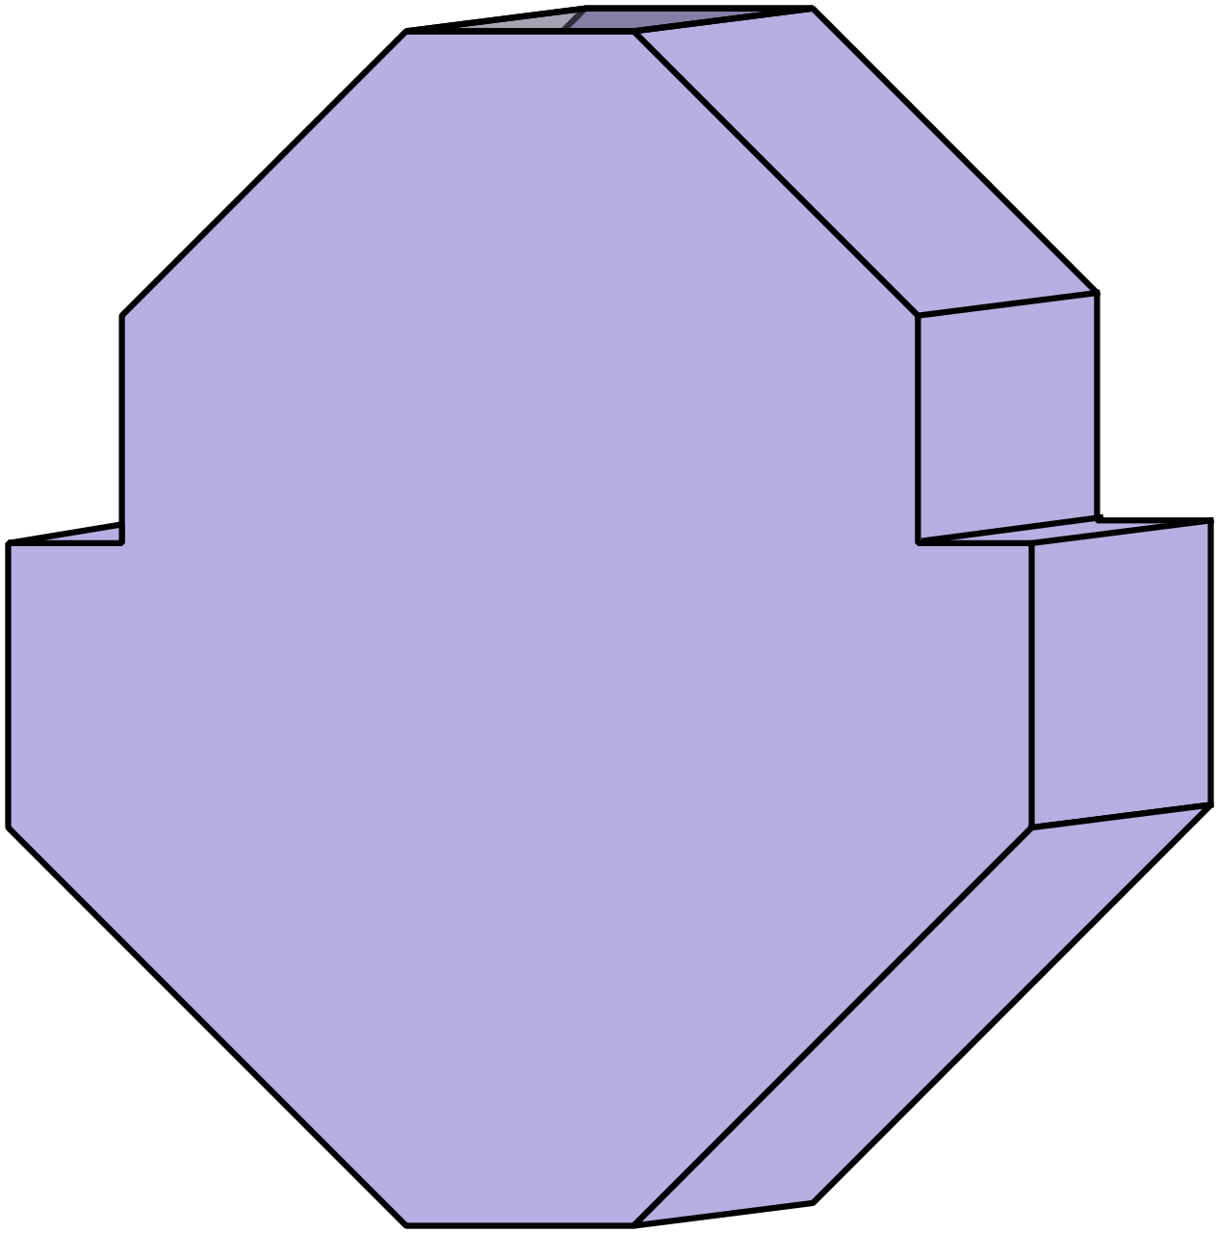

Which graph shows the rate at which the depth of the water (D) in the vase changes over time (T)?

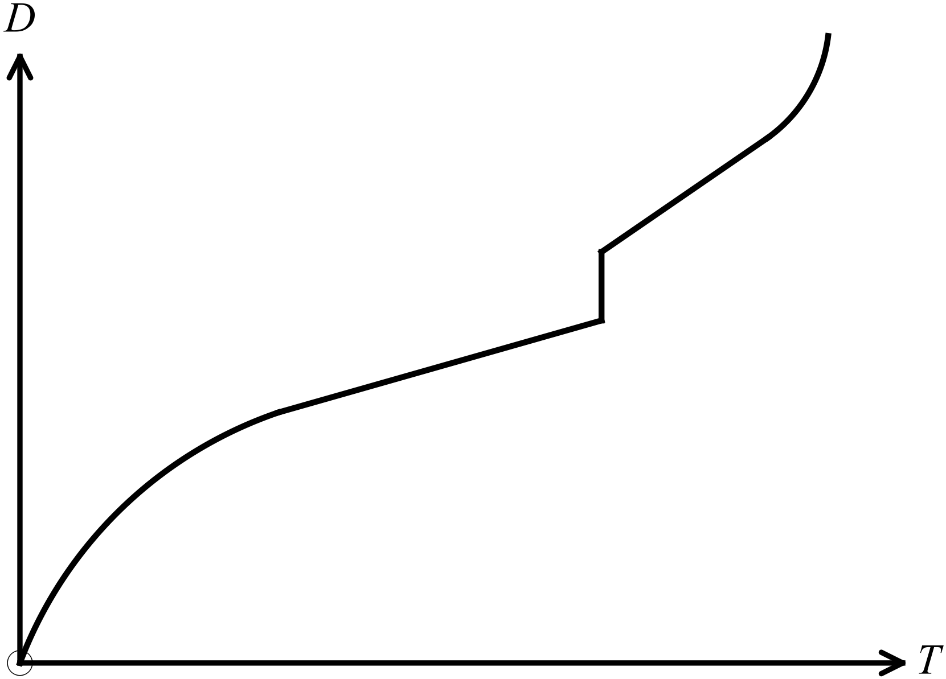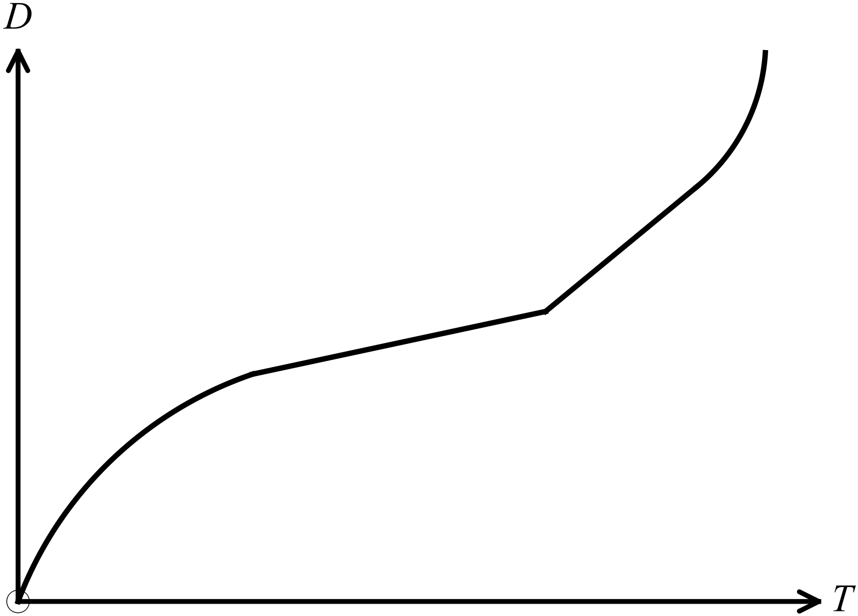 A. B.

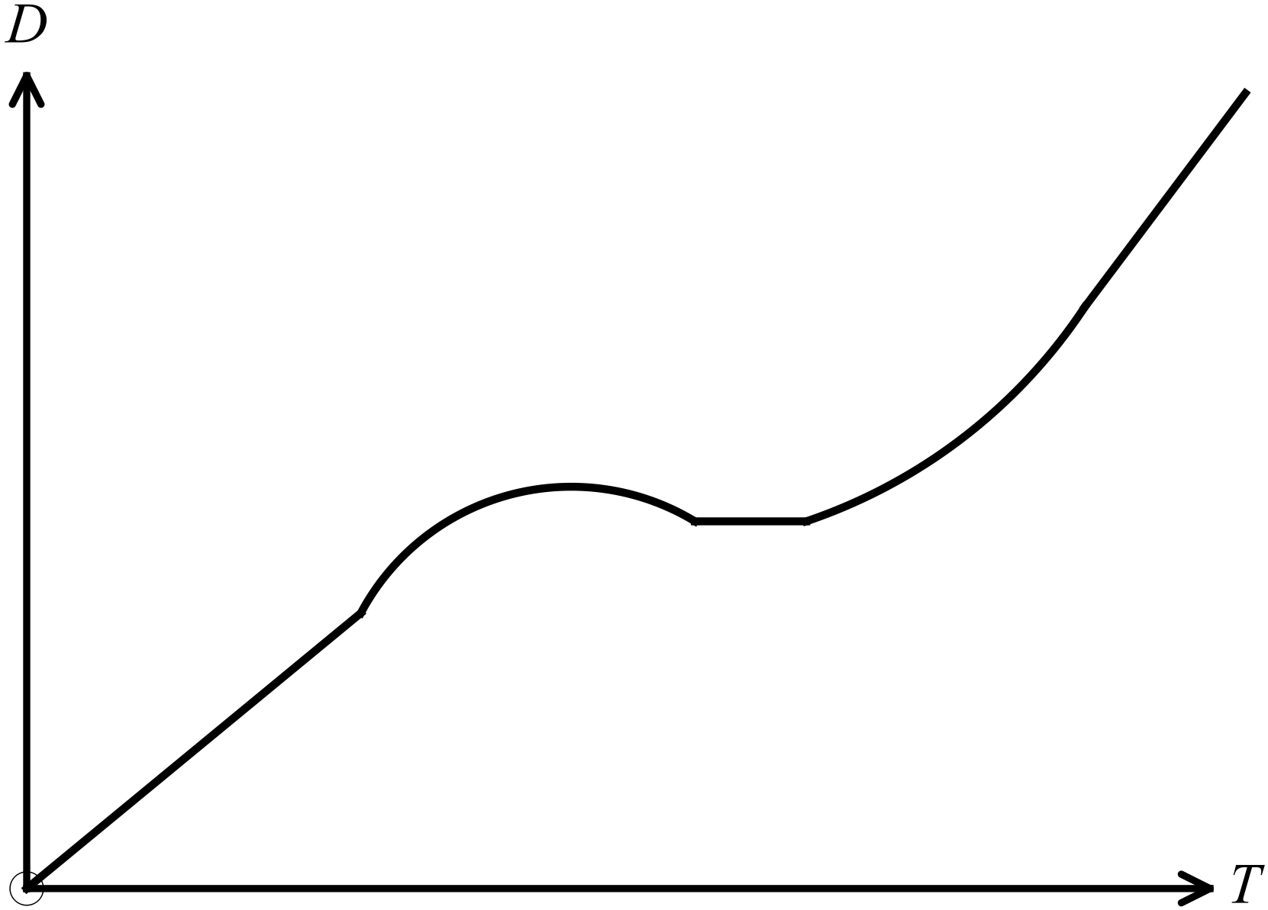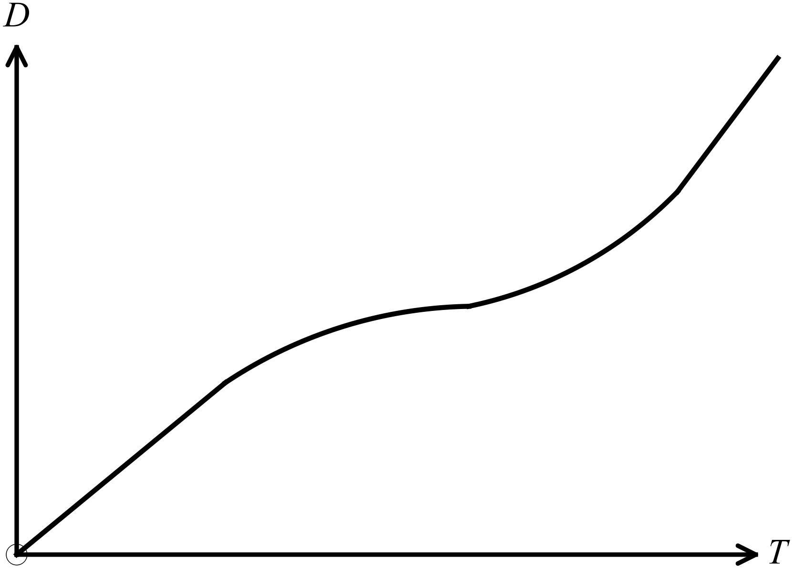 C. D.

Simplify 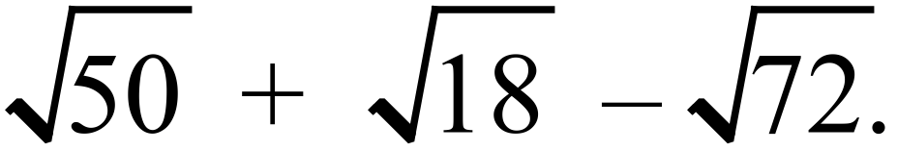

A. 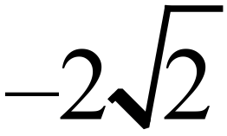 B. 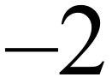 C. 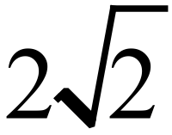 D. 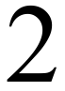
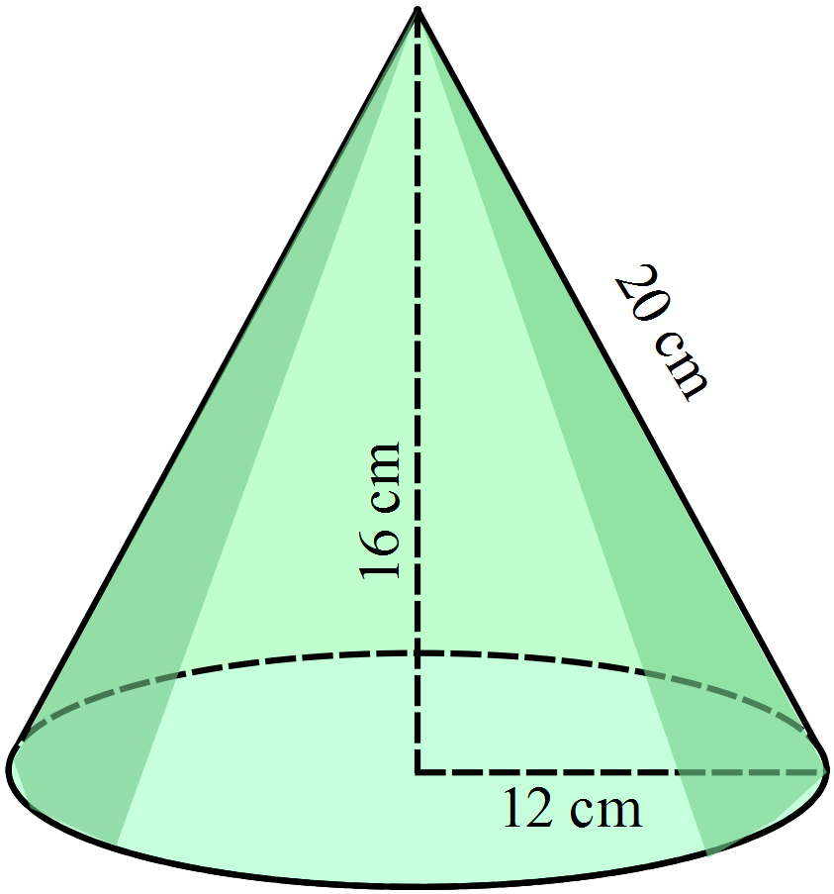Find the surface area of this cone.

A. 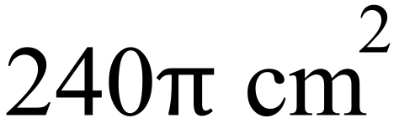
B. 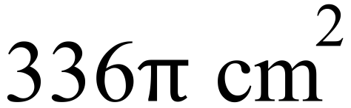
C. 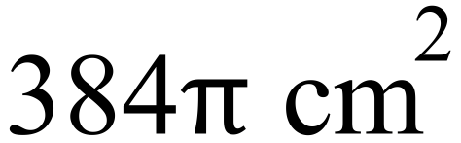
D. 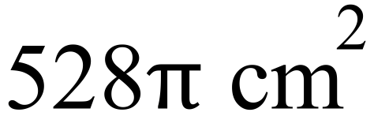

Solve 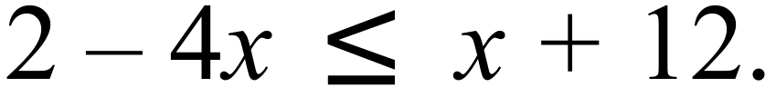

A. 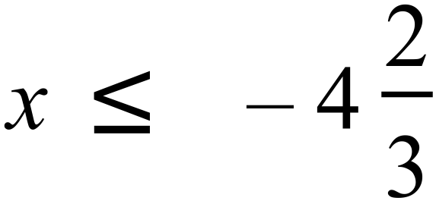 B. 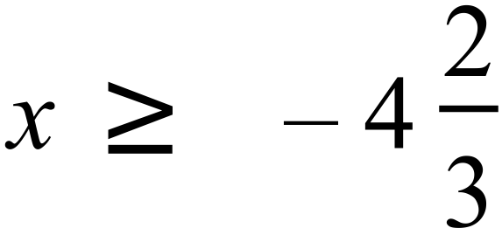 C. 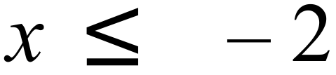 D. 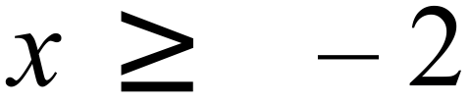
Expand 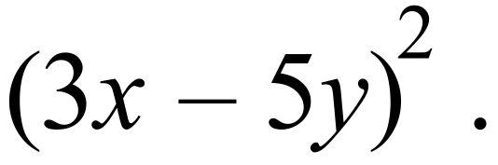

A. 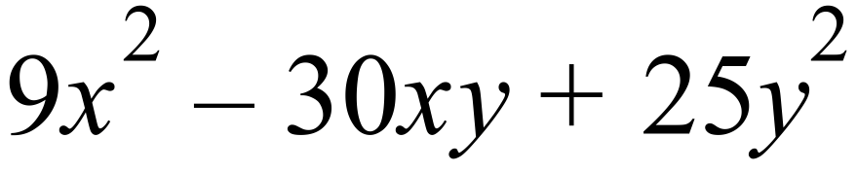 B. 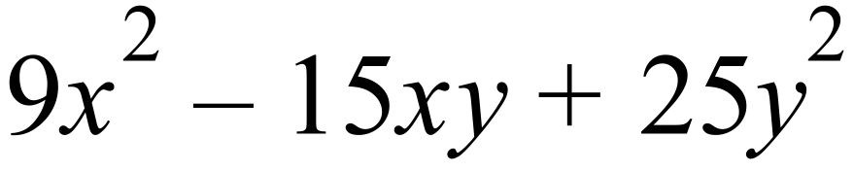
C. 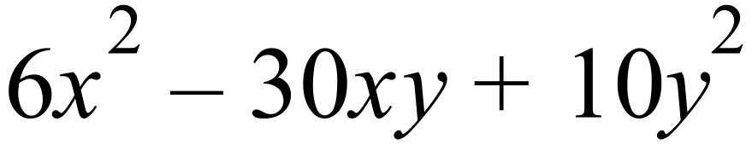 D. 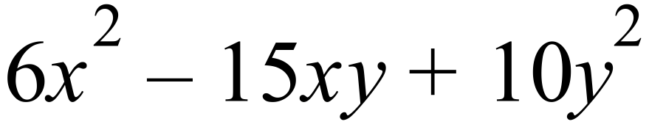
Leo invests $12 500 into an account that pays 7.2% p.a. interest, compounding monthly.
What is the value of the investment after a year and a half?

A. $12 612.67 B. $13 874.02 C. $13 921.10 D. $43 693.43
Matthew and Ben compare their results on two exams.
Exam | Ben’s Mark | Matthew’s mark | Mean | Standard Deviation
Physics | 88 | 81 | 68.0 | 6.5
Chemistry | 81 | 90 | 72.2 | 8.8
Which result is the best, relative to the other candidates for that exam?

A. Ben’s mark on Chemistry
B. Ben’s mark on Physics
C. Matthew’s mark on Chemistry
D. Matthew’s mark on Physics
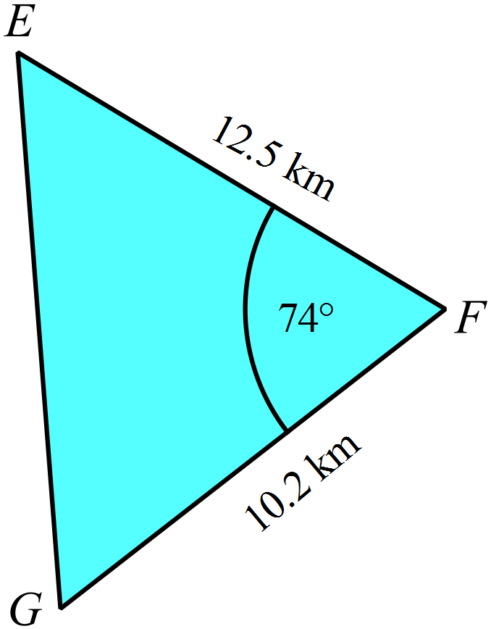What is the length of EG in this triangle?

A. 12.8 km
B. 13.8 km
C. 15.0 km
D. 17.2 km

ABCDEF is a regular hexagon.
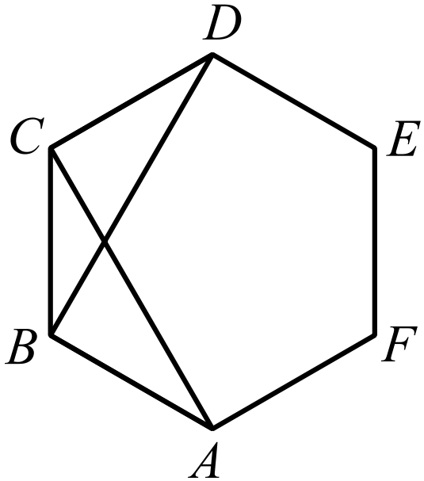Which congruence test could be used to prove that

A. AAS
B. RHS
C. SAS
D. SSS
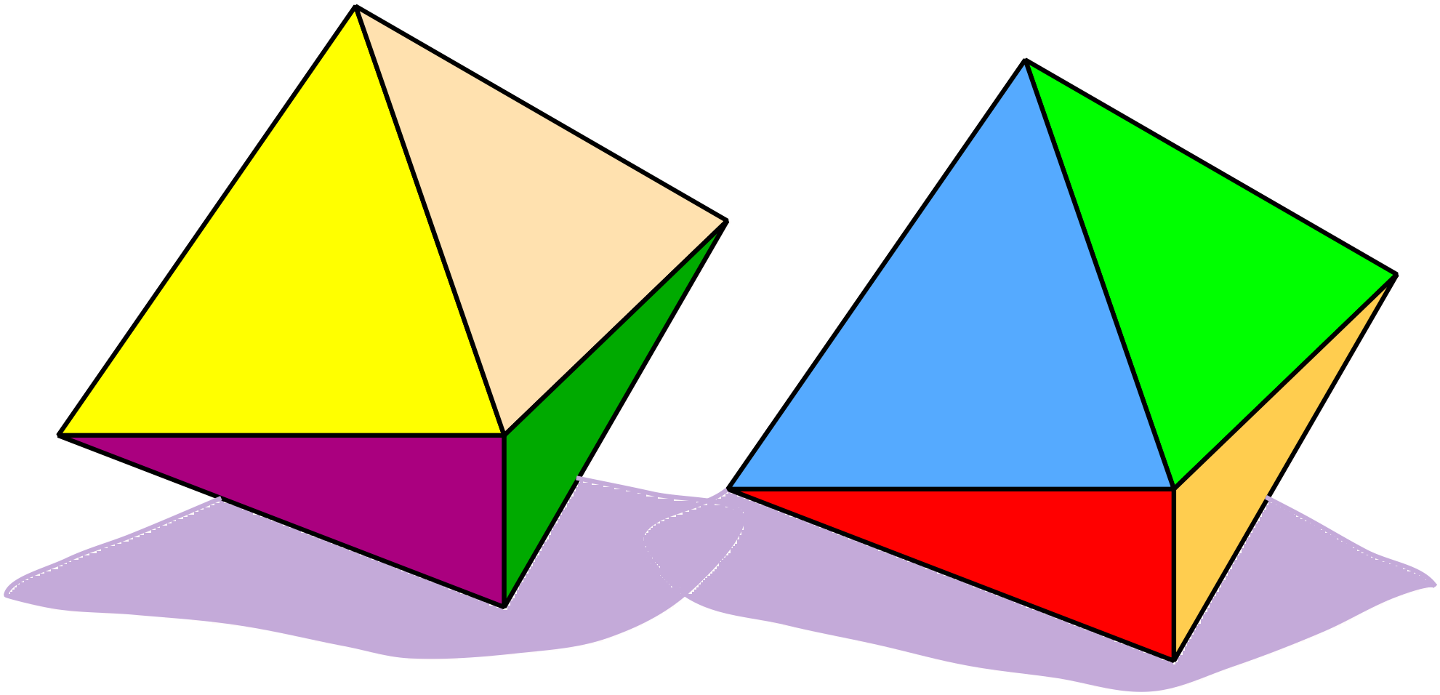Two regular octahedrons (solids with eight faces) are painted so that each of the 16 faces has a different colour.
The two are rolled along a table and the colour of the bottom face of each is recorded.
How many different pairs of colours are possible?
A. 16
B. 32
C. 64
D. 256
What is the equation of the line which has a gradient of  and passes through the point (12, 5) ?
A. 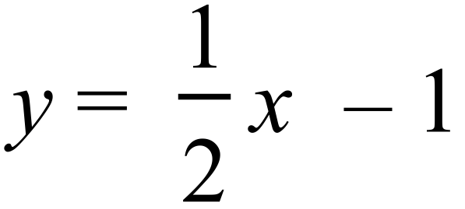
B. 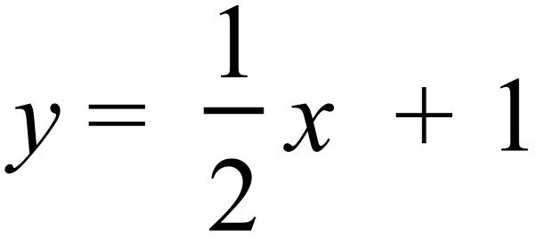
C. 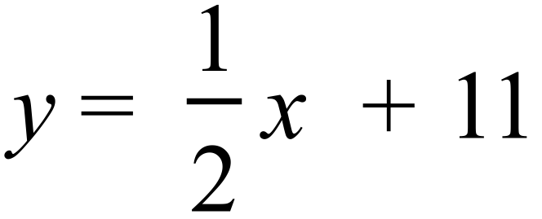
D. 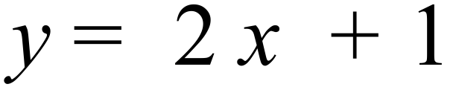
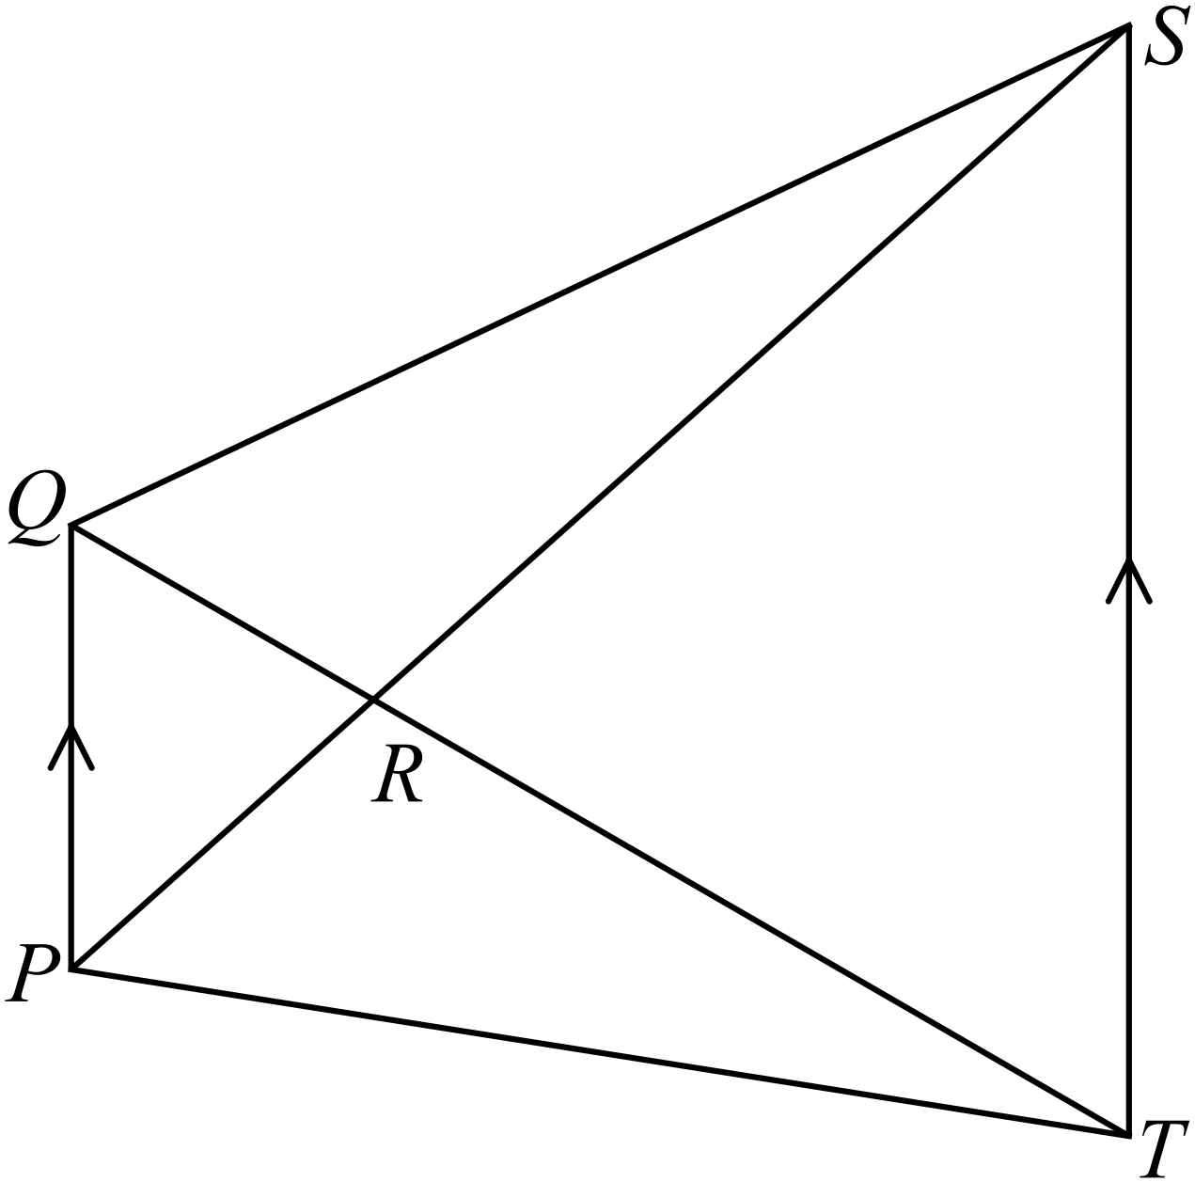Which is true?

A. 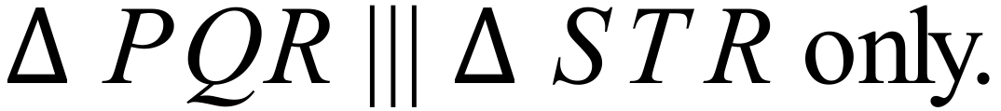
B.
C.
D. .

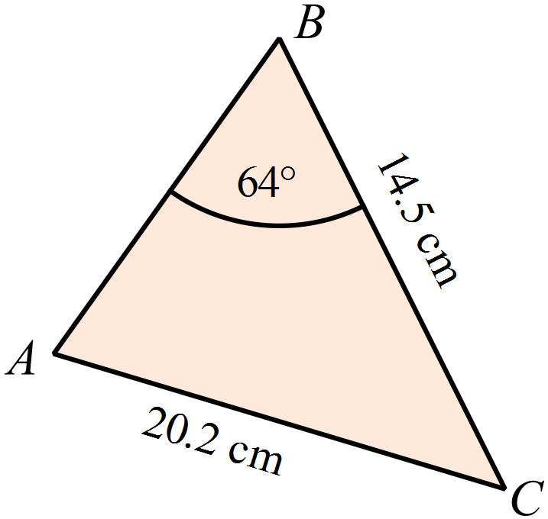What is the size of angle A in this triangle?

A. 19º
B. 23º
C. 32º
D. 40º

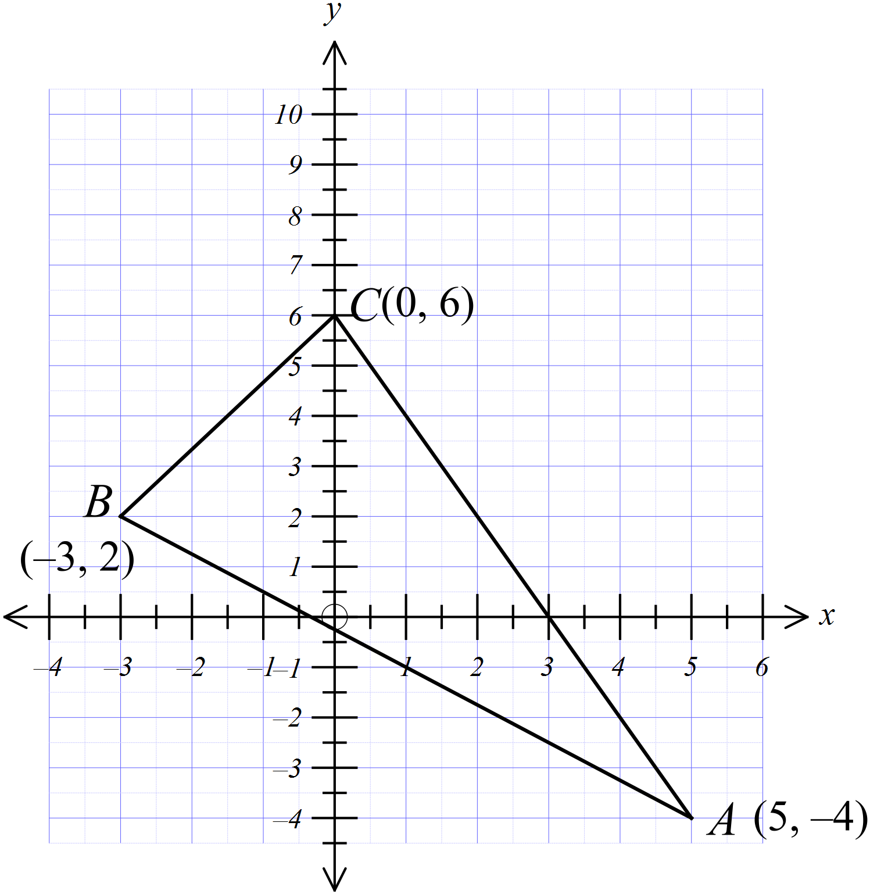A triangle is formed by the points A(5, –4), B(–3, 2) and C(0, 6).
Which is an accurate description of 

A. An equilateral triangle.
B. An isosceles triangle.
C. An obtuse angled triangle
D. A right angled triangle

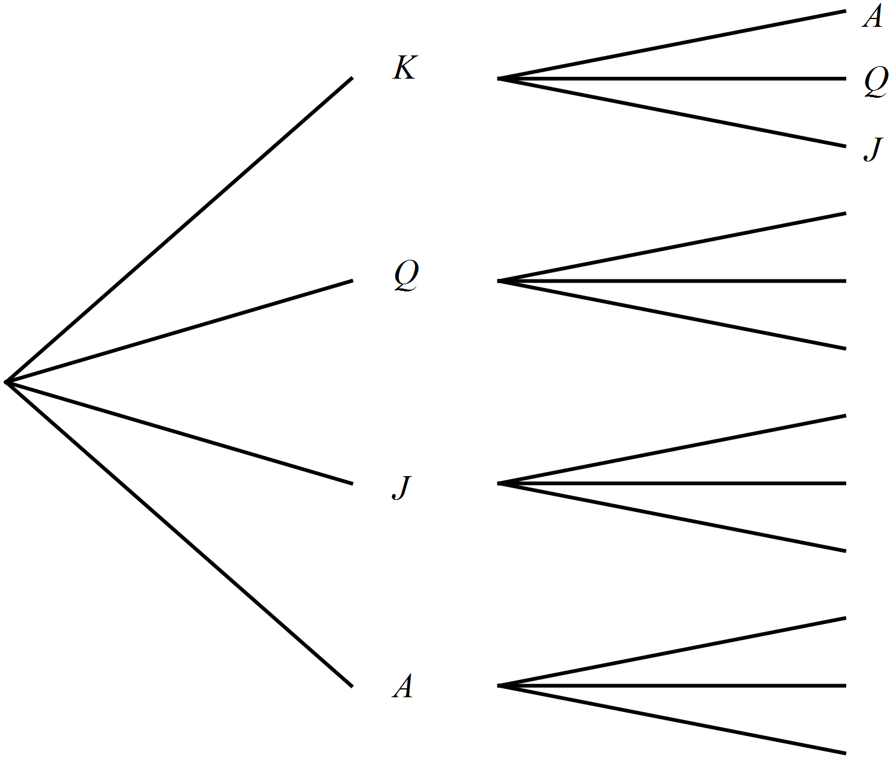Four cards, K, Q, J and A are shuffled and placed face down on a table.
Two cards are then chosen at random.
What is the probability that the K or Q or both are included in the chosen cards?
A.
B. 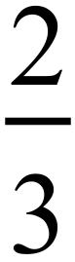
C. 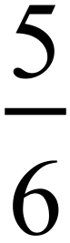
D. 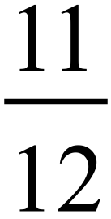
What are the solutions to 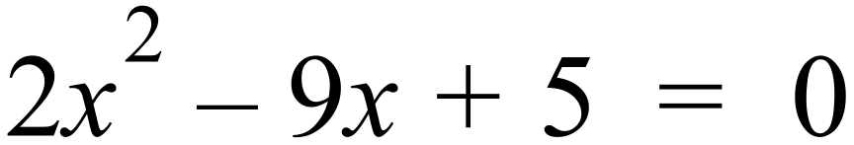.

A. 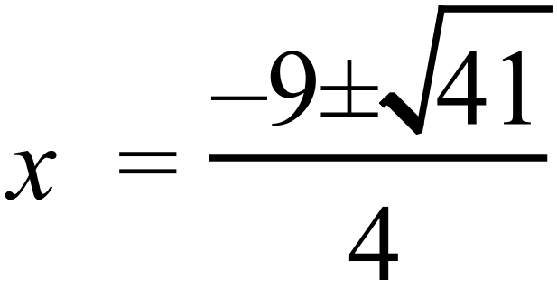 B. 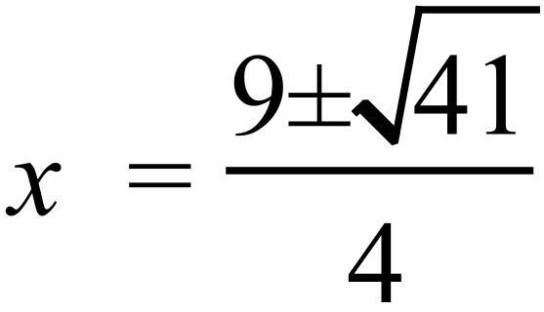 C. 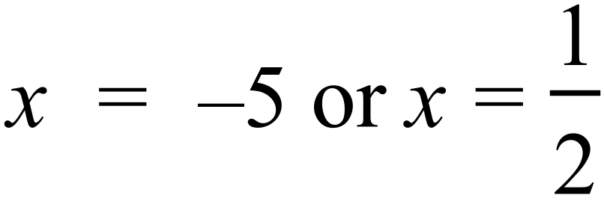 D. 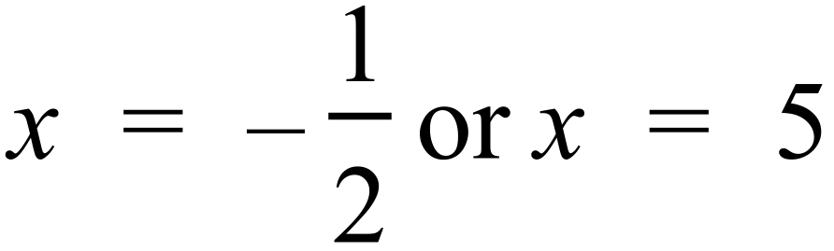
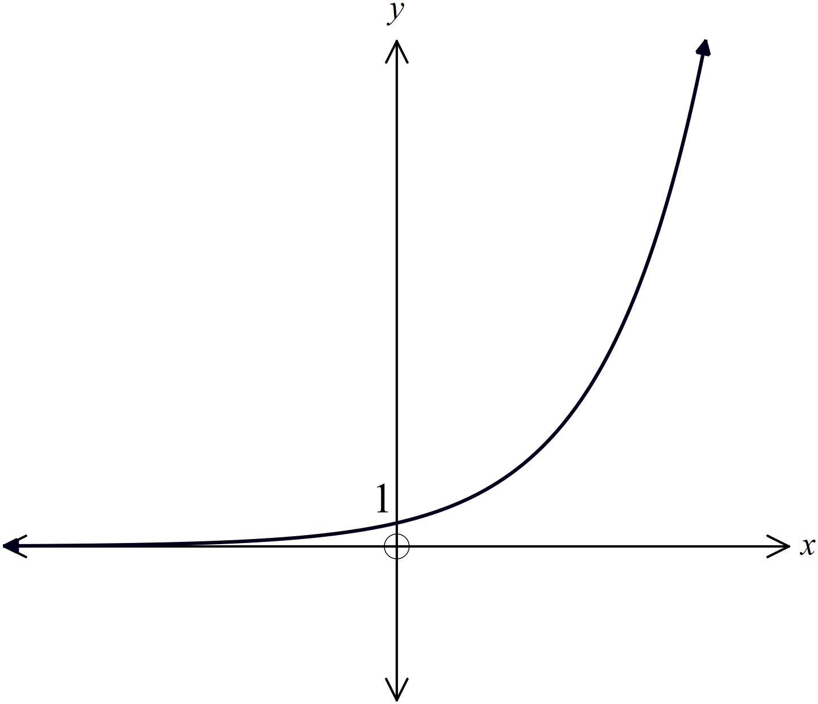Which equation could describe this graph?

A. 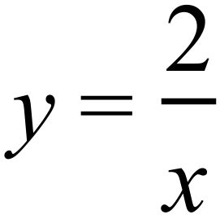
B. 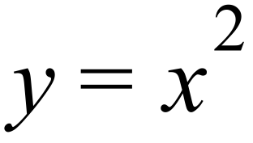
C. 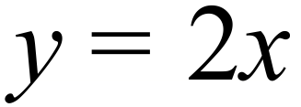
D. 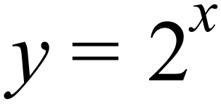

School Name  Yearly Examination  Year 10 |  | Advanced Mathematics Course  2015
Section 2  Part B  Longer Answer Section |  | Name : _______________________________
 |  | Class/Teacher___________________________
Write all working and answers in the spaces provided on this examination paper.
Calculators are allowed for this section.

 | Marks
76. | Agatha is a novelist and she recorded the number of pages she wrote each day over a period of a month. The results are shown in the frequency table below.
  Number of pages | Class Centre  x | Frequency  f | fx | Cumulative frequency.
  1 – 3 | 2 | 9 | 18 | 9
  4 – 6 | 5 | 10 | 50 | 19
  7 – 9 | 8 | 5 | 40 | 24
  10 – 12 | 11 | 3 | 33 | 27
  13 – 15 | 14 | 2 | 28 | 29
  16 – 18 | 17 | 1 | 17 | 30
   |  | 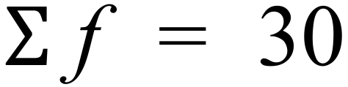 | 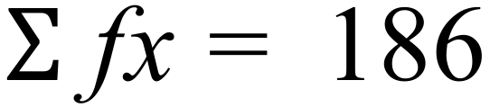
 | - Describe the shape of the distribution.  ……………………………………………………………………………………………....  ………………………………………………………………………………………………. | 1
 | - Calculate the mean of the data from the table.  ……………………………………………………………………………………………....  ………………………………………………………………………………………………. | 1
The cumulative frequency histogram and polygon for Agatha’s data has been draw.
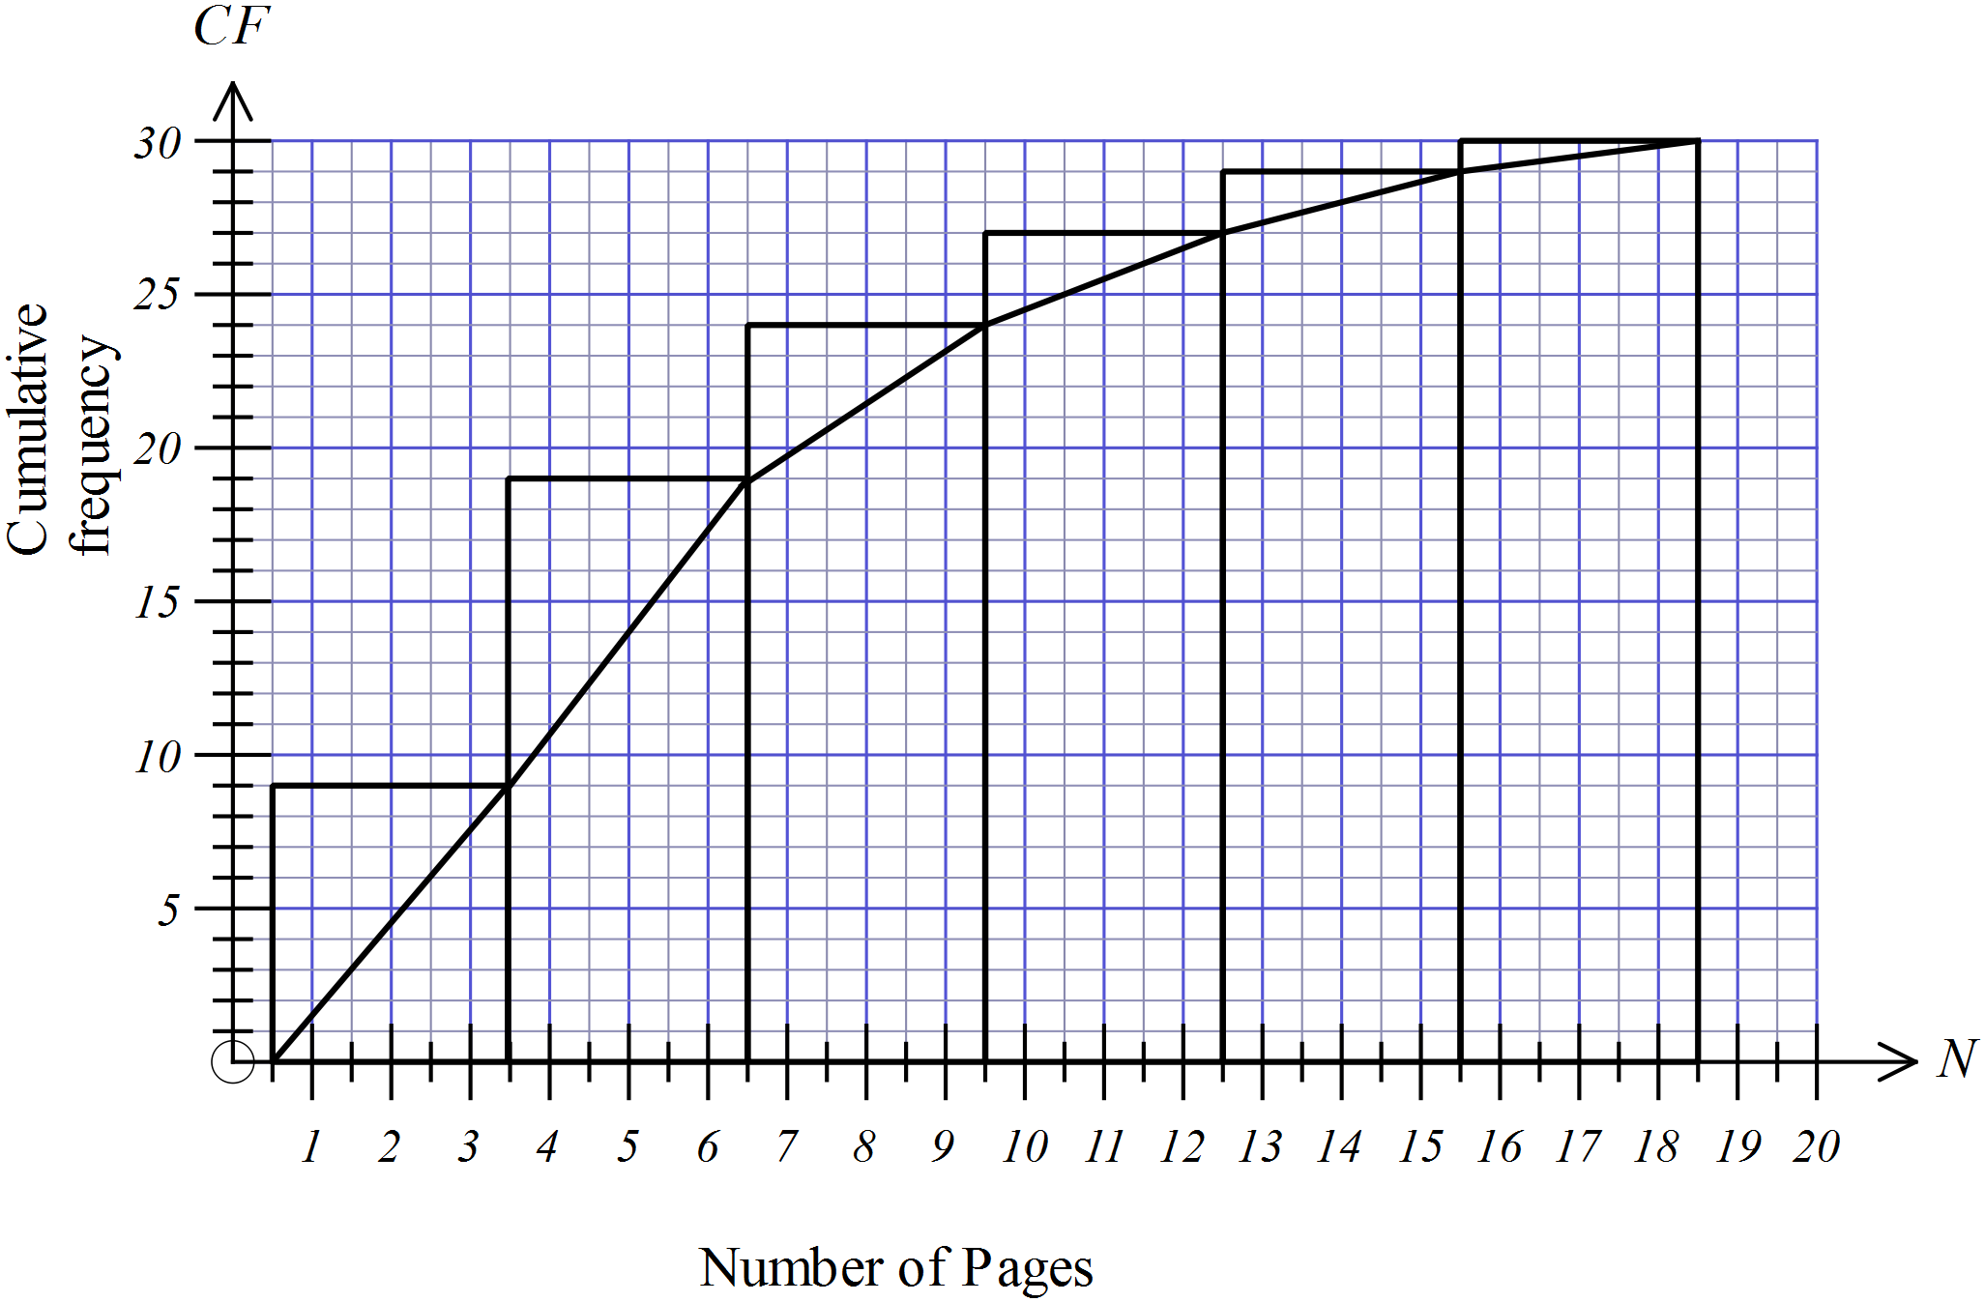

 | - Find an estimate for the interquartile range of the data.  ………………………………………………………………………………………………. | 1
 | - What is the standard deviation of the data?  ……………………………………………………………………………………………....  ………………………………………………………………………………………………. | 1
77. | - Simplify 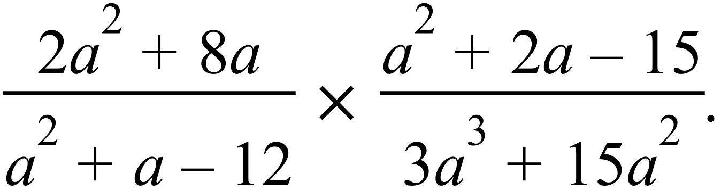  ……………………………………………………………………………………………....  ……………………………………………………………………………………………....  ………………………………………………………………………………………………. | 2
 | - Solve 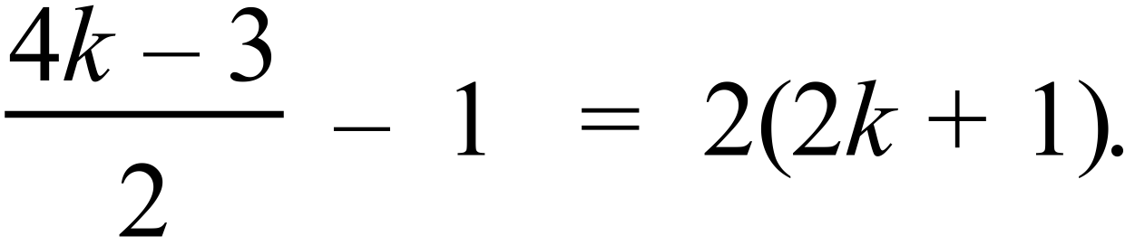  ……………………………………………………………………………………………....  ……………………………………………………………………………………………....  ………………………………………………………………………………………………. | 2
78. | 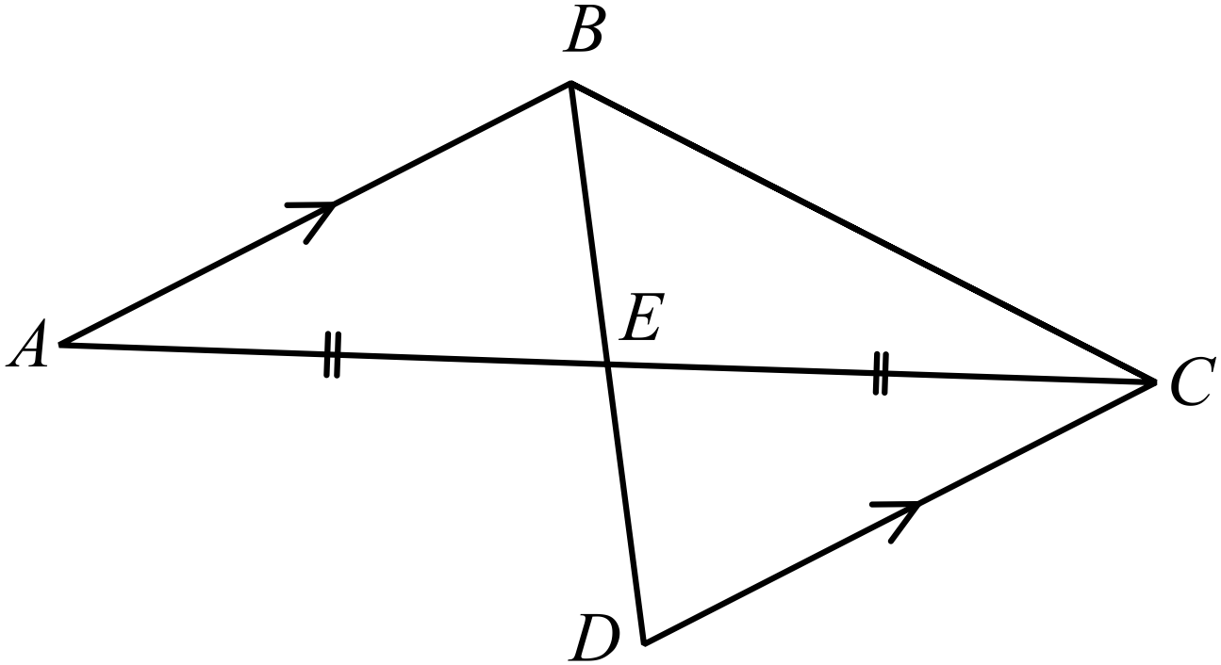In the diagram AB || DC and E bisects AC.  Prove that  ……………………………………………………………………………………………....  ……………………………………………………………………………………………….  ……………………………………………………………………………………………....  ……………………………………………………………………………………………….  ………………………………………………………………………………………………. | 2
79. | A block of land EFGH has the dimensions shown.  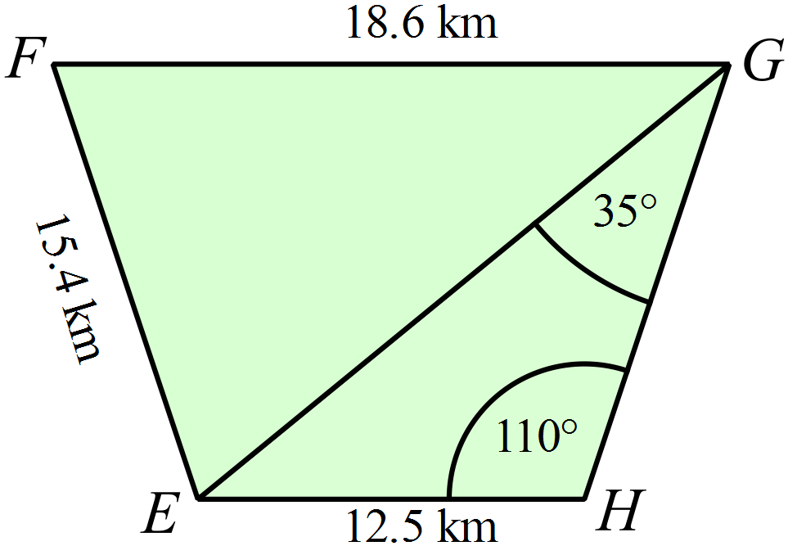
 | - Show that the distance EG is 20.5 km, to the nearest 100 m.  ……………………………………………………………………………………………....  ……………………………………………………………………………………………....  ………………………………………………………………………………………………. | 1
 | - Find the size of angle F.  ……………………………………………………………………………………………....  ……………………………………………………………………………………………....  ………………………………………………………………………………………………. | 1
 | - Find the area of 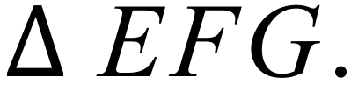  ……………………………………………………………………………………………....  ………………………………………………………………………………………………. | 1
80. | Two containers each hold three marbles which are red, white and blue.  The containers are shaken and a marble is randomly chosen from each.  A tree diagram has been started to show all the possible outcomes.  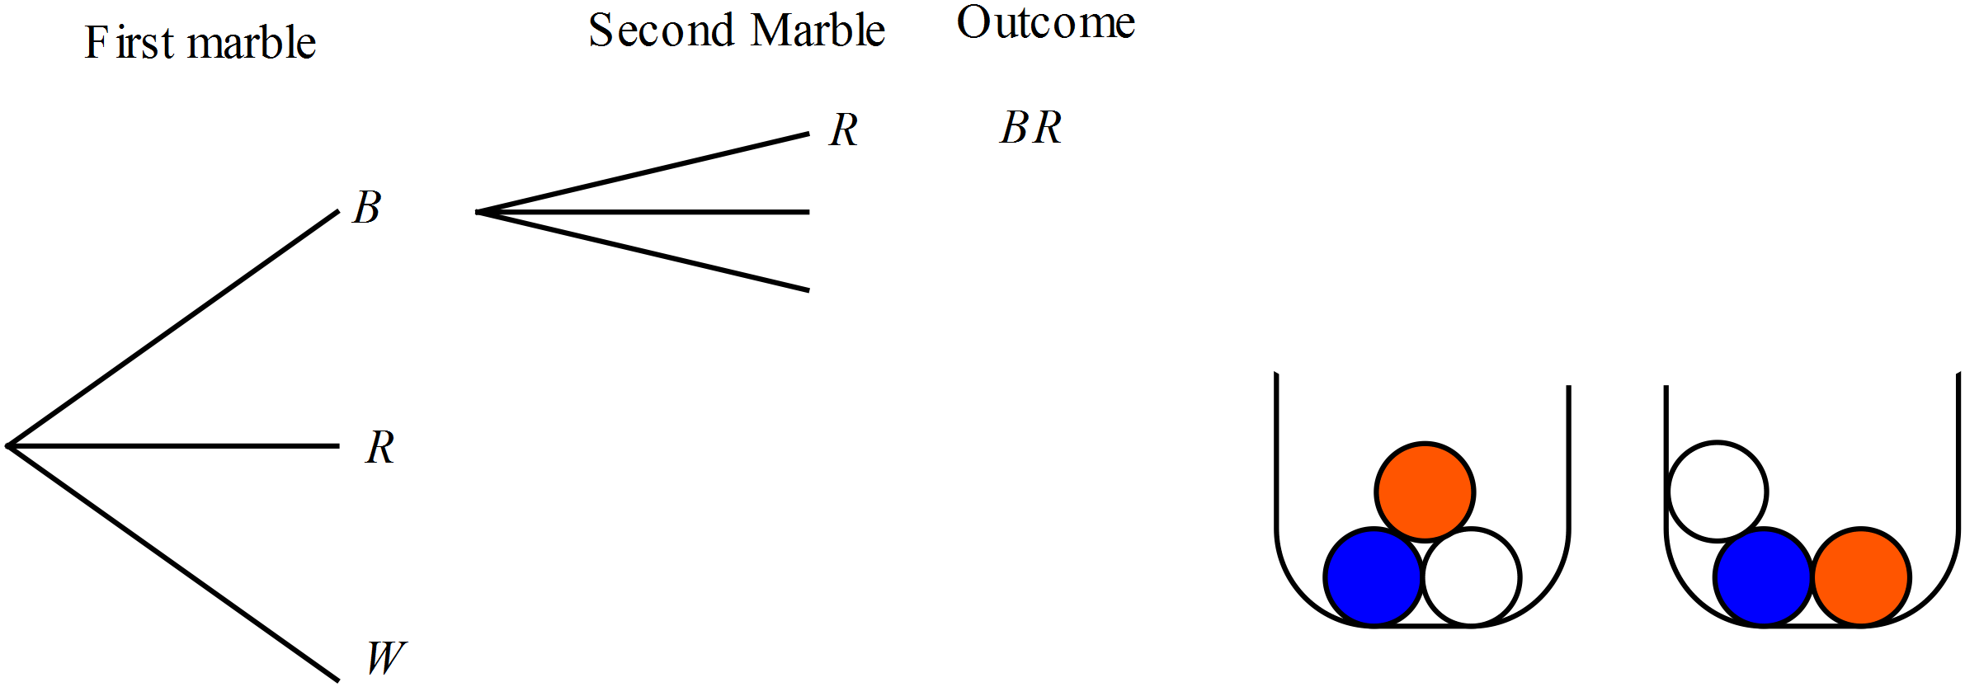
 | - Complete the tree diagram and the list of outcomes. | 1
 | - What is the probability that a blue marble is included in the two marbles chosen?  ……………………………………………………………………………………………....  ………………………………………………………………………………………………. | 1
 | - What is the probability that a blue marble or a red marble is included, but not both?  ……………………………………………………………………………………………....  ………………………………………………………………………………………………. | 1
81. | The points A (8, 8), B (-7, -3) and C (6, -5) are joined to form a triangle.  Show that the triangle is isosceles.  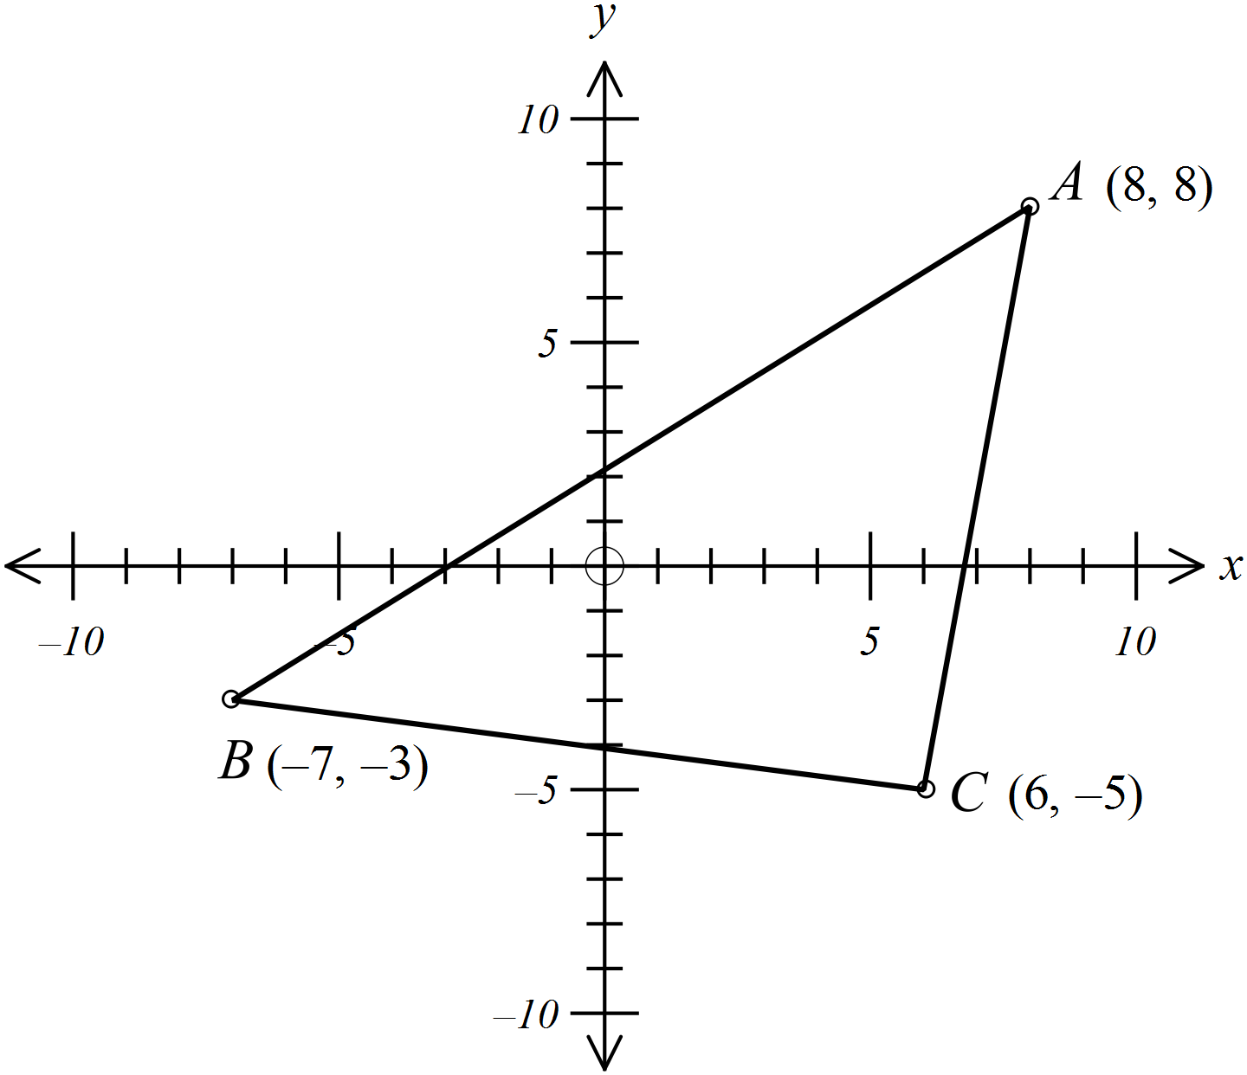  ……………………………………………………………………………………………....  …………………………………………………………………………………………….  ……………………………………………………………………………………………....  ……………………………………………………………………………………………. | 2
82. | - Solve  ……………………………………………………………………………………………....  ……………………………………………………………………………………………....  ………………………………………………………………………………………………. | 1
 | - Solve 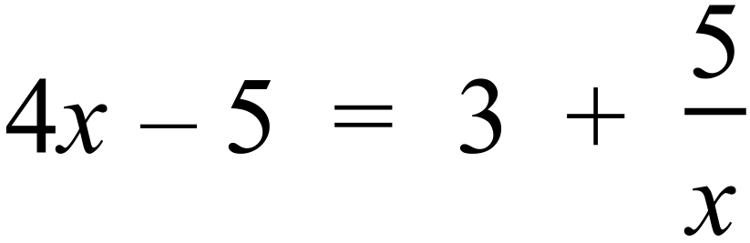  ……………………………………………………………………………………………....  ……………………………………………………………………………………………....  ……………………………………………………………………………………………....  ………………………………………………………………………………………………. | 2
83. | The graph of 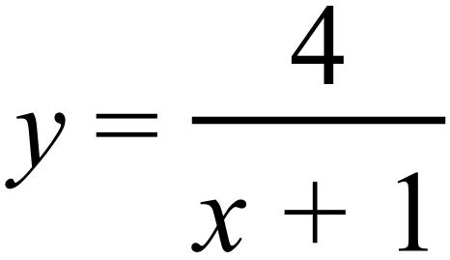 is shown on the grid below.  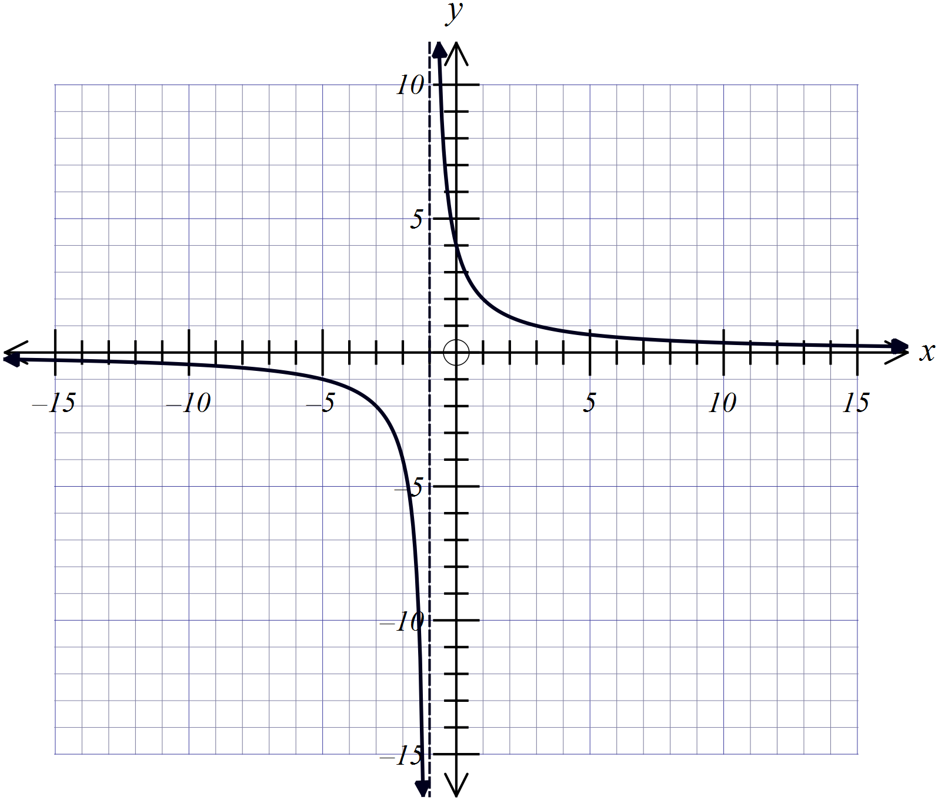
 | - On the same set of axes, draw the graph of 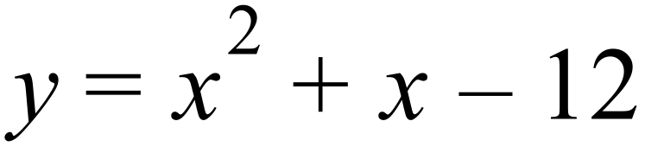 .  ……………………………………………………………………………………………....  ………………………………………………………………………………………………. | 2
 | - On the same set of axes, draw the graph of 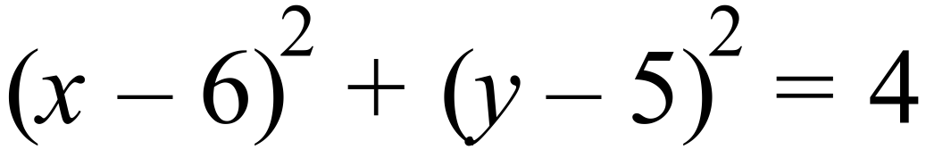 .  ……………………………………………………………………………………………....  ………………………………………………………………………………………………. | 1
 | - Estimate to the nearest half unit, the coordinates of the points of intersection between and .  ………………………………………………………………………………………………. | 1
 | End of Examination

School Name
Year 10 Yearly Examination
Advanced Mathematics Course 2015
Multiple Choice Section Answer Sheet
Name ________________________________ Teacher ________________________

Completely fill the response oval representing the most correct answer.
Use a black or blue pen or 2B pencil.

26. A B C D
27. A B C D
28. A B C D
29. A B C D
30. A B C D
31. A B C D
32. A B C D
33. A B C D
34. A B C D
35. A B C D
36. A B C D
37. A B C D
38. A B C D
39. A B C D
40. A B C D
41. A B C D
42. A B C D
43. A B C D
44. A B C D
45. A B C D
46. A B C D
47. A B C D
48. A B C D
49. A B C D
50. A B C D

51. A B C D
52. A B C D
53. A B C D
54. A B C D
55. A B C D
56. A B C D
57. A B C D
58. A B C D
59. A B C D
60. A B C D
61. A B C D
62. A B C D
63. A B C D
64. A B C D
65. A B C D
66. A B C D
67. A B C D
68. A B C D
69. A B C D
70. A B C D
71. A B C D
72. A B C D
73. A B C D
74. A B C D
75. A B C D

